جامعــــة الأزهــر – غـــــــــــــــزة

Al Azhar University - Gaza


DEPARTMENT OF MECHATRONICS ENGINEERING
FINAL YEAR PROJECT REPORT
Smart Traffic light

Said R. Albardawil 20202908
Ehab M. EL Sheikh Khalil 20200895
Abdullah M. Al-Madhoun 20202697
Oday A. Lafi 20202755

SUPERVISED BY
Dr. Hassan Abumeteir

September 2025

CERTIFICATE OF ORIGINALITY

This is to certify that I am responsible for the work submitted in this project, that the original work is my own except as specified in the references and acknowledgments, and that the original work contained herein has not been taken or done by unspecified sources or persons.

__________________________________________

Said R. Albardawil 20202908
Ehab M. EL Sheikh Khalil 20200895
Abdullah M. Al-Madhoun 20202697
Oday A. Lafi 20202755

ACKNOWLEDGEMENT

Praise be to God first and last, who has blessed us with His grace to complete the first project.

We would like to sincerely thank my supervisor, Dr. Hassan Abu Meteir, for his continuous guidance, helpful suggestions, careful supervision, and moral encouragement in completing this assignment.

We would like to thank everyone who helped us directly or indirectly to complete this project.

ABSTRACT

Urban traffic congestion is a global challenge exacerbated by inefficient fixed-time traffic lights. This project presents a Smart Traffic Light System that leverages computer vision and artificial intelligence to adjust signal timings based on real-time vehicle density dynamically. The system optimizes traffic flow autonomously using OpenCV for traffic analysis, Firebase for cloud-based data synchronization, and an ESP32 microcontroller for signal control. It reduces congestion, minimizes idling emissions, and enhances urban mobility by prioritizing high-density lanes. This scalable solution demonstrates the potential of AI-driven infrastructure to transform transportation efficiency.

Table of Contents

INTRODUCTION 10
1.1. Preamble 11
1.2. Problem Statement 13
1.3. Project Objective 15
1.4. Project Scope 17
1.4.1 Area of Specification 17
1.4.2 Targeted Users 18
1.4.3 Specific Platform 19
1.5. Project Stages 21
1.5.1 Research & Planning Stage 21
1.5.2 Design Stage 22
1.5.3 Development Stage 25
1.5.4 Testing & Prototyping 26
1.5.5 Backup Plan Development 27
1.5.6 Integration Stage 29
1.5.7 Final Testing & Demonstration 30
1.5.8 Implementation in a Real City (Final Stage) 30
1.6. Expected Output 33
Summary of Expected Outputs: 35
Chapter 2—Literature Review 36
2.1 Traditional Traffic Light Control 36
2.2 Adaptive Systems Using Sensors 37
2.3 Vision-Based Traffic Analysis 39
2.3.1 Deep Learning Approaches (YOLO, CNNs) 39
2.3.2 Lightweight Methods (OpenCV Pixel-Density Analysis) 41
Comparative Perspective 42
2.4 Cloud and IoT in Smart Transport 43
2.4.1 Cloud Computing for Traffic Control 43
2.4.2 Role of IoT in Transportation Networks 44
2.4.3 Firebase as a Real-Time Database 44
2.4.4 Limitations of Cloud and IoT Approaches 45
2.4.5 Comparative Advantage for Low-Cost Systems 45
2.5 Gap Analysis and Justification for Proposed Method ..47
2.5.1 Traditional Systems 47
2.5.2 Sensor-Based Adaptive Systems 47
2.5.3 Deep Learning Vision-Based Approaches 47
2.5.4 Lightweight Vision-Based Approaches 48
2.5.5 Identified Gap 48
2.5.6 Justification for Proposed Method 48
Chapter 3 — System Design and Architecture 50
3.1 Functional and Non-Functional Requirements 50
3.1.1 Functional Requirements 50
3.1.2 Non-Functional Requirements 51
3.2 High-Level Architecture 53
3.2.1 System Overview 53
3.2.2 Data Flow 54
3.2.3 Design Considerations 54
3.2.4 Advantages of the Architecture 54
3.3 Hardware Components and Bill of Materials (BOM) 55
3.3.1 Camera Module (USB/IP) 55
3.3.2 Camera Mounting Arm 55
3.3.3 Traffic Light Poles with LEDs 55
3.3.4 Intersection Base 56
3.3.5 Model Vehicles 56
3.3.6 Laptop / Server / Single-Board Computer (Raspberry Pi) 56
3.3.7 ESP32 Microcontroller 57
3.3.8 Bill of Materials (Prototype Version) 57
3.3.9 Summary 58
3.4 Software Tools and Libraries 58
3.4.1 Python as the Primary Development Language 58
3.4.2 OpenCV for Computer Vision Processing 59
3.4.3 NumPy and cvzone Libraries 59
3.4.4 Firebase for Real-Time Cloud Integration 60
3.4.5 Arduino Framework for ESP32 60
3.4.6 Development and Testing Environment 61
3.4.7 Summary 61
3.5 Use Cases and Scenarios 62
3.5.1 Heavy Traffic in One Direction 62
3.5.2 Balanced Traffic Across All Lanes 62
3.5.3 Pedestrians and Non-Vehicle Objects 63
3.5.4 Network Failure (Cloud Unavailable) 63
3.5.5 Testing with a 3D Modeled Intersection 64
3.5.6 Summary 64
3.6 Conclusion of Chapter 3 65
Chapter 4 – Implementation 66
4.1 Computer Vision Pipeline (Python – OpenCV) 66
4.1.1 Stage 0 — Original Frame 66
4.1.2 Stage 1 — Grayscale Conversion 67
4.1.3 Stage 2 — Gaussian Blurring 68
4.1.4 Stage 3 — Thresholding 68
4.1.5 Stage 4 — Morphological Opening 69
4.1.6 Stage 5 — Dilation 70
4.1.7 Stage 6 — Morphological Closing 71
4.1.8 Stage 7 — Final Refinement 71
4.1.9 Traffic Density Calculation 72
4.1.10 Performance Analysis 72
4.1.11 Summary of the Pipeline 73
4.2 Firebase Integration 74
4.2.1 Role of Firebase in the System 74
4.2.2 Data Structure in Firebase 74
4.2.3 Writing Data from the Vision Module 75
4.2.4 Reading Data on ESP32 75
4.2.5 Advantages of Using Firebase 76
4.2.6 Limitations and Mitigations 76
4.2.7 Summary 76
4.3 ESP32 Traffic Light Controller 77
4.3.1 Role of ESP32 in the System 77
4.3.2 Hardware Mapping and GPIO Assignments 77
4.3.3 Data Retrieval from Firebase 78
4.3.4 Decision-Making Algorithm 78
4.3.5 Finite State Machine (FSM) 79
4.3.6 Fail-Safe and Backup Mode 79
4.3.7 Prototype Demonstration 80
4.3.8 Advantages of Using ESP32 80
4.3.9 Summary 81
Chapter 5 – Prototype and Testing Setup 82
5.1 Physical Prototype of Intersection 82
5.1.1 Intersection Base 82
5.1.2 Traffic Light Poles with LEDs 83
5.1.3 Camera and Mounting Arm 83
5.1.4 Model Vehicles 84
5.1.5 System Integration in Prototype 84
5.2 Testing with 3D Modeled Video 85
5.2.1 Purpose of the 3D Modeled Video 85
5.2.2 Video Generation Process 86
5.2.3 Test Scenarios Simulated 86
5.2.4 Benefits of Using Synthetic Video 87
5.2.5 Summary 88
5.3 FPS Measurement and Hardware Benchmarks 89
5.3.1 Importance of Performance Analysis 89
5.3.2 Results of the Proposed Method 89
5.3.3 YOLO Baseline Results 89
5.3.4 Comparative Analysis 91
5.3.5 Discussion of Results 91
5.3.6 Summary 92
5.4 Latency Analysis (Image → Firebase → ESP32 Cycle) 93
5.4.1 Measured Latencies 93
5.4.2 Implications for Real-Time Traffic Control 94
5.4.3 Comparison with Deep Learning Systems 94
5.4.4 Summary 94
5.5 Summary of Prototype and Testing 95
Chapter 6 – Results and Evaluation 96
6.1 Performance Results 96
6.1.1 Frame Rate Performance 96
6.1.2 Latency Performance 96
6.1.3 Comparison with YOLO-Based Systems 97
6.2 Scenario Evaluation 97
6.2.1 Heavy Traffic in One Direction 97
6.2.2 Balanced Traffic Across All Lanes 97
6.2.3 Pedestrian and Non-Vehicle Interference 98
6.2.4 Network Failure Scenario 98
6.3 Comparative Evaluation 98
6.3.1 Traditional Fixed-Time Systems 98
6.3.2 Sensor-Based Adaptive Systems 99
6.3.3 Deep Learning Vision-Based Systems (YOLO, CNNs) 99
6.3.4 Proposed Method (Pixel-Density Approach) 99
6.3.5 Comparative Summary Table 100
6.4 Discussion of Results 100
6.4.1 Real-Time Responsiveness 100
6.4.2 Cost Efficiency 101
6.4.3 Robustness in Real-World Scenarios 101
6.4.4 Scalability and Expansion 101
6.4.5 Comparison with Alternatives 102
6.5 Limitations of the System 102
6.5.1 Implicit Vehicle Weighting 102
6.5.2 Dependence on Camera Placement 102
6.5.3 Sensitivity to Environmental Conditions 102
6.5.4 Network Dependency 103
6.5.5 Limited Long-Term Deploymen 103
6.6 Overall Evaluation 103
Chapter 7 — Conclusion and Future Work 105
7.1 Conclusion 105
7.2 Contributions of the Project 106
7.2.1 Technical Contributions 106
7.2.2 Practical Contributions 107
7.3 Future Work 108
7.3.1 Multi-Intersection Coordination 108
7.3.2 Advanced Camera Capabilities 108
7.3.3 Integration with Vehicle-to-Infrastructure (V2I) Communication 108
7.3.4 Hybrid AI Approaches 108
7.3.5 Long-Term Field Testing 109
7.3.6 Data Analytics and Prediction 109
7.4 Final Remarks 110
References .....................................................................................111
Appendices ...................................................................................112

Table of Figures

Figure 1: System Architecture Diagram 12
Figure 2: Process Flowchart of the Smart Traffic Light System 24
Figure 3: Project Timeline 32
Figure 4: Original frame (Stage 0) 67
Figure 5: Grayscale conversion (Stage 1) 67
Figure 6: Gaussian blur (Stage 2) 68
Figure 7: Thresholded image (Stage 3) 69
Figure 8: Morphological opening (Stage 4) 70
Figure 9: Dilated image (Stage 5) 70
Figure 10: Morphological closing (Stage 6) 71
Figure 11: Final refined mask (Stage 7) 72
Figure 12: Top view of the intersection prototype 82
Figure 13: SolidWorks model with traffic light poles and vehicles 83
Figure 15: ESP32 microcontroller and Raspberry Pi integrated under the intersection base 85
Figure 16: Simulation of heavy traffic in one direction with priority assignment 86
Figure 17:shows the simulation where pedestrians are present, but the system continues to focus only on vehicles. 87
Figure 18: Object Detection Benchmark on Raspberry Pi and Jetson Orin NX with YOLOv8s 90

Chapter 1—INTRODUCTION

Preamble
The rapid urbanization of cities worldwide has brought about a significant increase in vehicle numbers, leading to severe challenges in managing traffic congestion. According to the World Health Organization (WHO), urban air pollution, primarily caused by vehicle emissions, is responsible for approximately 4.2 million premature deaths annually. The inefficient traffic management contributes to these health issues and results in significant economic losses. In the United States alone, traffic congestion costs over $87 billion annually due to lost productivity, fuel waste, and time spent idling in traffic, as the Texas A&M Transportation Institute reported. Furthermore, the global rise in urban vehicle population, projected to reach 2 billion vehicles by 2040, underscores the urgency of addressing traffic management issues effectively.
Traditional traffic control methods, such as timed traffic lights and manual adjustments, are no longer adequate in handling modern traffic's dynamic and ever-changing nature. These methods fail to respond to real-time traffic conditions, causing congestion during peak times and inefficiencies at intersections. As a result, there is a growing need for intelligent, adaptive traffic management solutions that can optimize traffic flow, reduce congestion, and mitigate environmental impacts.
This project aims to tackle these challenges by developing a Smart Traffic Light System Using Computer Vision. By leveraging computer vision technologies and artificial intelligence (AI), the proposed system will use real-time video feeds from cameras to monitor traffic conditions and dynamically adjust traffic light timings based on the detected density of vehicles on each street. This system is designed to prioritize vehicles on busier streets, reduce waiting times at intersections, and alleviate congestion, contributing to the overall efficiency of urban transportation networks.

System Architecture
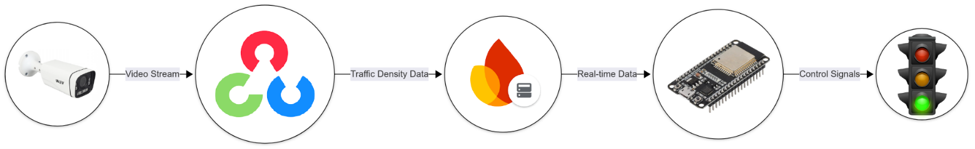
The system’s architecture integrates hardware and software components to enable real-time traffic monitoring and adaptive control. Figure 1 illustrates the high-level design:
Figure 1: System Architecture Diagram

Figure 1: System Architecture Diagram

Key Components:
- Input Layer: IP cameras capture live traffic footage.
- Processing Layer: Computer vision algorithms (OpenCV) analyze vehicle density.
- Cloud Layer: Firebase stores and synchronizes data across devices.
- Control Layer: ESP32 adjusts traffic lights based on real-time data.
The integration of cloud technologies and the Internet of Things (IoT) plays a pivotal role in the system’s functionality. Cloud computing allows for storing and processing large amounts of traffic data in real-time, enabling the system to handle traffic monitoring and decision-making without overburdening local hardware. By storing data in the cloud, the system can be accessed and managed remotely, providing flexibility in monitoring and controlling traffic across multiple intersections simultaneously. Additionally, the IoT framework connects various smart devices, such as traffic cameras, sensors, and microcontrollers, enabling seamless communication and data exchange across the traffic management network.
This project aims to implement a scalable and adaptive traffic control system that utilizes cloud-based data storage, real-time analytics, and IoT integration to optimize traffic light control. The system will be capable of handling urban traffic complexities and learning from traffic patterns to improve its decision-making processes continually. By dynamically adjusting traffic signals based on real-time data, the system will reduce congestion, minimize fuel consumption, and decrease the environmental footprint of urban transportation.

Problem Statement
Urban areas worldwide are facing unprecedented challenges due to the rapid increase in population and the subsequent rise in the number of vehicles on the roads. According to the World Bank, the global urban population is expected to reach 68% by 2050, which will further exacerbate the strain on existing infrastructure, particularly in transportation systems. Traffic congestion has become one of the most significant issues in modern cities, leading to numerous problems, including:
- Increased Traffic Congestion: Inefficient traffic light systems that operate on fixed timers fail to adapt to real-time traffic conditions. As a result, certain intersections experience excessive waiting times, especially during rush hours, leading to a significant buildup of vehicles and delays in transportation.
- Environmental Pollution: Traffic congestion directly contributes to the emission of harmful pollutants. According to the Environmental Protection Agency (EPA), vehicle emissions account for approximately 30% of global air pollution, contributing to increased greenhouse gas emissions and air quality deterioration in urban environments
- Economic Losses: Congested roads lead to a loss in productivity. According to the Texas A&M Transportation Institute, congestion in the U.S. alone costs over $87 billion annually in wasted fuel and lost time. These inefficiencies not only affect daily commuters but also impact businesses that rely on timely deliveries and transportation.
- Increased Fuel Consumption: Vehicles that are stuck in traffic or idling at red lights consume more fuel, contributing to higher fuel costs and environmental damage. The International Energy Agency (IEA) estimates that traffic congestion increases fuel consumption by over 20% during peak hours in major cities.

Current traffic light systems are primarily designed to operate on fixed timers or preset cycles, which do not account for traffic flow or density variability. These systems operate based on assumptions rather than real-time data, leading to unnecessary delays and inefficiencies. As cities grow, this method becomes increasingly inadequate.
Moreover, traditional traffic light systems cannot often prioritize lanes based on traffic density or respond dynamically to changing conditions. These systems are not equipped to manage the complexities of modern urban traffic, where traffic volume and behavior can change rapidly throughout the day.
The problem lies in the lack of an adaptive, real-time traffic management solution that can:
- Monitor traffic density on each street in real time.
- Adjust traffic light timings dynamically based on current traffic conditions.
- Minimize waiting times, reduce congestion, and enhance the overall flow of traffic.
- Contribute to environmental sustainability by optimizing fuel consumption and reducing emissions.
The objective of this project is to develop a smart traffic light system using computer vision to address these issues. The system will utilize real-time data collected from IP cameras and computer vision algorithms to analyze traffic conditions and dynamically adjust traffic lights. By utilizing cloud technologies and IoT, the system will be scalable, efficient, and adaptable to changing traffic conditions, offering a solution to the urban transportation challenges that many cities face today.

Project Objective
The primary objective of this project is to design, develop, and implement a Smart Traffic Light System Using Computer Vision to optimize traffic flow and reduce congestion in urban environments. This system aims to dynamically control traffic light timings based on real-time traffic conditions, ensuring intersections operate efficiently and effectively while minimizing delays and environmental impact.
Specifically, the project seeks to:
- Develop a Real-Time Traffic Monitoring System:
  - To utilize computer vision techniques and IP cameras to capture live video footage of traffic at intersections. This system will process the video data to detect vehicle presence, count vehicles, and estimate traffic density on each street in real-time.
- Implement Dynamic Traffic Light Control:
  - To create an adaptive traffic light system that adjusts the state of traffic lights (green, yellow, red) based on the detected traffic density. The system will prioritize lanes with higher traffic flow to optimize the movement of vehicles, reducing waiting times and improving overall traffic efficiency.
- Integrate Cloud Technologies for Real-Time Data Processing:
  - To incorporate cloud computing and IoT technologies, ensuring the real-time synchronization of traffic data across multiple intersections. The system will store traffic density data in Firebase, allowing for remote monitoring, management, and control of the traffic lights.
- Optimize Traffic Flow and Reduce Congestion:
  - To enhance traffic management by reducing unnecessary waiting times at intersections. By dynamically adjusting traffic signals based on real-time traffic conditions, the system will contribute to the smoother flow of traffic and alleviate congestion, particularly during peak hours.
- Contribute to Environmental Sustainability:
  - To reduce fuel consumption and emissions by minimizing the time vehicles spend idling at traffic lights. With more efficient traffic light management, the system aims to decrease the overall carbon footprint of urban transportation.
- Create a Scalable and Adaptive System:
  - To design the system to be scalable, meaning it can be implemented across multiple intersections in a city. The system will learn from real-time data and adapt to evolving traffic patterns over time, continuously improving its decision-making capabilities.
- Provide a Flexible and User-Friendly Interface:

  - To develop a Python-based GUI app that will allow for the visualization and monitoring of traffic conditions and traffic light control in real-time. This app will provide a clear interface for users to interact with the system and receive feedback on traffic flow.
By achieving these objectives, the project aims to provide a cost-effective, scalable, and sustainable solution for managing urban traffic, contributing to the development of smart cities, and improving the overall quality of urban transportation.

Project Scope
This project's scope defines the boundaries and objectives for developing the Smart Traffic Light System. It focuses on providing an innovative solution to optimize traffic flow, reduce congestion, and improve urban transportation systems using computer vision, cloud technologies, and IoT. The system will be designed to be adaptable to real-world traffic conditions, scalable across multiple intersections, and efficient in both operational and environmental aspects
The key aspects of the project scope include:
- Designing and implementing a smart traffic light system with real-time traffic monitoring and dynamic traffic light control.
- Integration of advanced technologies such as computer vision for vehicle detection, cloud computing for data storage and processing, and IoT for connecting various system components.
- Testing and deployment of the system in a small-scale urban intersection environment for real-world validation.
The project will cover the development of the system's hardware and software components, including the cameras, processing device, microcontroller, and cloud infrastructure, and will extend to integrating the system into real-world scenarios for testing and improvement.

Area of Specification
The Area of Specification defines the specific components and technological boundaries within the Smart Traffic Light System. This includes the physical scope of deployment, the technologies involved, and the environment in which the system will be tested and implemented.
- Geographical Scope: The system is designed to be implemented in urban environments, specifically at intersections with heavy traffic congestion. The initial deployment will focus on small-scale urban intersections, with the potential for scalability to more complex intersections and broader urban areas.
- Traffic Management Scope: The system will be responsible for real-time monitoring of traffic flow at intersections, with the ability to adjust traffic light timings dynamically based on traffic density. It will primarily manage traffic at intersections, but the design allows for future expansion to manage entire road networks within a city.
- Technology Scope: The system will use IP cameras for traffic monitoring, computer vision algorithms for vehicle detection and density analysis, and cloud computing (via Firebase) to store and process real-time traffic data. The IoT framework will connect all components of the system, allowing for seamless communication.
between the cameras, processing devices, and traffic light controllers.
- Environmental Scope: The system will be developed for use in typical urban environments with varying traffic conditions, weather, and lighting. It will be designed to function effectively under these varying conditions, ensuring reliable performance during both peak and off-peak hours.

Targeted Users
The targeted users of the smart traffic light system are primarily those responsible for the design, management, and monitoring of urban traffic systems. However, it also benefits the broader community, including drivers and pedestrians.
- City Planners and Traffic Authorities: The primary users of the system will be municipalities and transportation authorities responsible for managing city traffic. The system will assist in optimizing traffic flow, reducing congestion, and improving road safety. These users will interact with the system to configure, monitor, and analyze traffic data, adjusting settings as necessary to meet evolving traffic demands.
- Urban Transportation Engineers: These professionals will use the system to study traffic patterns, improve traffic management strategies, and enhance the planning and development of transportation infrastructure. They will leverage the data collected by the system to make informed decisions about traffic signal timing and urban road design.
- Drivers and Commuters: While not directly interacting with the system, drivers and commuters will benefit from improved traffic flow and reduced congestion at intersections. The system’s real-time adjustments will help minimize waiting times, providing a smoother and more efficient driving experience.
- City Residents and Pedestrians: The ultimate goal of the system is to create a safer, more efficient urban environment, benefiting not only drivers but also pedestrians and residents who are affected by the overall quality of transportation and air quality. By reducing congestion and vehicle emissions, the system will contribute to the overall well-being of the community.

Specific Platform
The specific platform refers to the hardware, software, and technological environment in which the smart traffic light system will be built and deployed. This platform defines the tools, technologies, and components that will be used to implement the system effectively.
- Hardware Platform:

  - IP Cameras: These cameras will serve as the primary input for real-time traffic monitoring. Positioned at key points in the intersection, they will capture video data to be processed by the system.
  - Processing Server: A dedicated processing server or Raspberry Pi will handle the real-time data processing of video feeds, applying computer vision algorithms to detect vehicles and estimate traffic density.
  - ESP32 Microcontroller: The ESP32 microcontroller will interface with the traffic light hardware and Firebase, enabling the real-time adjustment of traffic signals based on the processed data.
- Software Platform:
  - Computer Vision Algorithms: The system will use OpenCV or similar libraries for vehicle detection, counting, and traffic density analysis. These algorithms will run on the processing device/server.
  - Cloud Platform: The system will rely on Firebase for real-time data storage and synchronization across multiple devices. Cloud technologies ensure that the system can handle data from various intersections and be remotely monitored and controlled.
  - IoT Communication: The platform will incorporate an IoT framework to connect all system components (cameras, processing devices, and microcontrollers) via Wi-Fi or Ethernet, ensuring seamless data exchange and decision-making.
- User Interface:

  - The system will include a Python-based GUI app that will serve as a visual interface for monitoring the traffic light system. This app will allow users (such as traffic authorities) to observe traffic flow and adjust settings remotely based on the real-time data from Firebase.

Project Stages
The development of the Smart Traffic Light System is organized into several key stages to ensure the project's progression is structured, efficient, and aligned with the final goal of developing an adaptive traffic light system that uses computer vision for real-time traffic management. Below is the breakdown of the stages:

Research & Planning Stage
The research & planning stage is essential to lay the groundwork for the entire project. This phase focuses on understanding the technologies available, the system requirements, and how to approach the project’s goals. Without adequate planning and research, the project could face unnecessary obstacles down the line.
- Research on Smart Traffic Lights: The first step in the project is to conduct thorough research on smart traffic light systems, which are designed to optimize traffic flow in urban environments. These systems typically use real-time data to adjust traffic light timings, reducing congestion and improving traffic management. Existing systems are examined, focusing on how they incorporate technologies like sensors, cameras, and machine learning. In particular, the focus is on using computer vision to track and analyze traffic density, which can be leveraged to inform traffic light control systems.

- Define Project Scope: Once the research is completed, the project scope is defined. This includes identifying what the system will achieve, such as using computer vision to monitor traffic and adjust traffic lights in real time. The specific hardware and software needed for this project are outlined, including:

  - Hardware: Webcam or camera for traffic video capture, microcontroller (e.g., ESP32) for controlling traffic lights, and a server or Raspberry Pi for processing the video data.
  - Software: Computer vision algorithms (e.g., OpenCV) for vehicle detection and traffic density analysis, Firebase for storing real-time data, and a user interface for visualizing traffic light control.

- Select Technologies & Tools: During this phase, the tools and technologies to be used are finalized. This includes selecting the programming languages, frameworks, and hardware components. For example:
  - Processing Device
The Raspberry Pi, laptop, or a dedicated processing server will be used to run the computer vision algorithms and handle data processing.
  - Computer Vision
OpenCV, a powerful computer vision library, will be used to process the video feed from the camera, detect vehicles, and estimate traffic density.
  - Data Storage & Communication
Firebase is selected as a cloud-based solution to store the real-time data about vehicle density, ensuring that the system can synchronize across different devices.
  - Microcontroller:
The ESP32 microcontroller will be used to read the data from Firebase and control the traffic light LEDs.
The research and planning stage sets a clear direction for the project and helps identify potential risks and challenges. By understanding the system requirements and tools needed early on, this stage ensures that the development and design phases proceed without major delays.

Design Stage
The design stage is where the system's architecture and prototype are planned. This phase focuses on visualizing the end product and creating a working model of the intersection to test and validate the traffic light control system.
- Prototype Design: During the design stage, a prototype of the crossroad model is created. This physical model will simulate a real intersection with streets, traffic lights, and vehicles. Materials such as wood, plastic, and paper are used to create the miniature streets and traffic lights. This prototype allows the team to visually demonstrate how the traffic light system will work in a real-world setting.
- System Architecture: In this phase, the system's overall architecture is designed. The architecture outlines how each component of the system interacts with the others. The system consists of several key elements:
  - Camera: Captures real-time video footage of the intersection.
  - Processing Device: Runs the computer vision algorithms to analyze traffic density.
  - Firebase Database: Stores and synchronizes traffic density data in real-time, making it accessible to other system parts.
  - ESP32 Microcontroller: Reads the traffic density data from Firebase and controls the LEDs on the traffic lights based on the analyzed data.
  - Traffic Light Control: The LEDs on the traffic lights will be adjusted based on the traffic density, switching from green to yellow to red according to which street has the most traffic.

Operational Workflow
Figure 2 illustrates the step-by-step process of the Smart Traffic Light System:
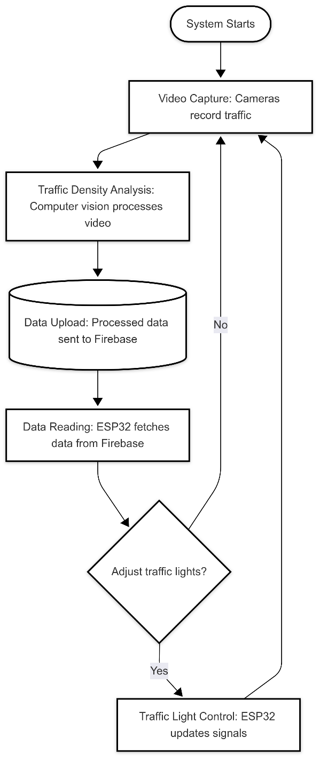
Figure 2: Process Flowchart of the Smart Traffic Light System

Key Features:
- Continuous loop for real-time adaptation
- The decision node ensures dynamic adjustments
- Integration of all core components (cameras, Firebase, ESP32)
The design stage is crucial for visualizing how the system will function as a whole and for identifying any design flaws or potential improvements before moving into the development phase.

Development Stage
The development stage is where the system is built and implemented. During this stage, the hardware is set up, and the software is written to make the system operational.
- Hardware Setup:
  - Processing Device Setup: The processing device (such as a Raspberry Pi, laptop, or server) is set up to handle the video capture and processing tasks. The camera is mounted at the intersection to monitor traffic in real time.
  - ESP32 Setup: The ESP32 microcontroller is programmed to read traffic density data from Firebase and adjust the LEDs on the traffic lights based on the data.
  - Prototype Setup: The miniature intersection model is completed, with traffic lights and vehicles (toys or small models) installed in the model.
- Software Development:
  - Computer Vision Implementation: The core computer vision code is developed and implemented on the processing device. This code uses OpenCV to process the video feed from the camera and detect vehicles on the street. By counting the number of vehicles detected, the system estimates the traffic density on each street.
  - Firebase Integration: The system is programmed to upload traffic density data to Firebase in real-time. This ensures that the traffic density information is always updated and can be accessed by other components of the system, such as the ESP32.
  - ESP32 Code: The microcontroller is programmed to monitor the Firebase database for changes in traffic density. Based on the density data, the microcontroller adjusts the state of the traffic lights (green, yellow, and red).

- Testing & Debugging: After the initial development, rigorous testing is conducted to ensure that all components work together as expected. This includes checking the accuracy of the computer vision system, ensuring that the data flows correctly between the camera, processing device, Firebase, and ESP32, and verifying that the traffic lights are properly controlled based on real-time traffic conditions.

Testing & Prototyping
The testing & prototyping stage involves testing the physical prototype and evaluating the system’s performance. This stage ensures that the system works as expected before finalizing the design.
- Prototype Testing: The physical prototype is tested to ensure that it correctly simulates a real-world intersection. The camera captures video of the traffic flow, and the computer vision system analyzes the footage to detect vehicles and calculate traffic density. The traffic lights are then adjusted based on the data, and the system’s accuracy is evaluated.
- System Performance Evaluation: During this phase, the system’s performance is assessed to ensure that it can accurately analyze traffic conditions and adjust traffic lights accordingly. Various scenarios are tested, such as different traffic densities, vehicle types, and traffic light transitions. The system is monitored to ensure that it responds to real-time traffic conditions without delay.
- ESP32 Testing: The ESP32 is tested to verify that it correctly reads the traffic density data from Firebase and adjusts the traffic lights based on this data. The system’s latency is also tested to ensure that the traffic lights change in a timely manner.

Backup Plan Development
In the event of hardware limitations or unavailable components, such as the webcam or ESP32 microcontroller, backup plans are essential to ensure the continued development and functionality of the Smart Traffic Light System. For this project, the backup plan revolves around two main alternatives: creating a 3D model in SolidWorks and developing a Python GUI app. These alternatives will serve as substitutes for real-time camera data and microcontroller functionality, allowing for continued testing and demonstration of the system.
- 3D Model Creation (in SolidWorks): If the webcam is unavailable for real-time traffic monitoring, a 3D model of the intersection will be created using SolidWorks. This 3D model will simulate the real-world environment of the intersection, including the layout of streets, traffic lights, and vehicles, to test the computer vision algorithms and the traffic light control logic.

  - Creation of the 3D Model:
Using SolidWorks, the intersection’s geometry, including the roads, traffic lights, and vehicles, is modeled with precision. The 3D model will replicate the actual dimensions of the streets and traffic infrastructure used in the physical setup. The vehicles in the model will be animated to move along the streets, simulating real traffic flow.
  - Traffic Simulation:
An animation is generated to simulate the flow of traffic, where vehicles are added and removed from the intersection based on predefined rules or random generation. The traffic density on each street will be modeled to replicate different traffic conditions, allowing the system to adjust the traffic light accordingly.

  - Computer Vision Algorithms:
The computer vision algorithms designed for analyzing traffic flow will be applied to the 3D model. This includes identifying the density of traffic on each street and making decisions on which street should have a green light based on the density.
  - Integration with Firebase:
The traffic density data from the 3D model simulation will be uploaded to Firebase in real-time, just as it would in the physical system. This ensures that the Firebase integration is fully tested even without real-time data capture from the webcam.

- Python GUI App Development: If the ESP32 microcontroller is unavailable, a Python-based GUI application will be developed to simulate the traffic light control system. This app will read real-time traffic density data from Firebase and simulate the operation of traffic lights on a computer screen, replacing the physical ESP32-controlled traffic lights.
  - Functionality of the Python GUI App
The Python GUI app will be designed to read the traffic density data from Firebase and adjust the status of virtual traffic lights (green, yellow, red) in real-time. The app will provide a visual interface where users can monitor the traffic light system and observe how traffic lights change based on the density of traffic on each street.
  - User Interface Design
The user interface of the app will be designed using Tkinter or PyQt. It will display virtual traffic lights for each street of the intersection, along with real-time traffic density data. Users will be able to observe how the traffic lights are adjusted based on the density data sent from Firebase.

  - Integration with Firebase
Just like the ESP32, the Python GUI app will continuously read traffic density data from Firebase. The app will simulate how the traffic light control system operates by changing the color of the virtual traffic lights based on the highest density street, ensuring the traffic flow is managed effectively.

Integration Stage
At this stage, all components are integrated into a cohesive system that functions as intended. This stage ensures that the system works as a unified whole, with all components communicating and performing their tasks without any issues.
- System Integration: All the components, including the camera, processing device, Firebase, ESP32, and traffic light LEDs, are integrated. The system is tested as a whole to ensure that all components work together seamlessly. The camera will feed real-time video to the processing device, which processes the data and uploads the traffic density to Firebase. The ESP32 will then read the data and control the traffic lights accordingly.
- Real-Time Functionality Testing: The system undergoes testing in real-time, where the camera captures live footage, the processing device analyzes the video, and the traffic lights are adjusted based on real-time traffic density data from Firebase. This ensures the system works continuously without issues.

Final Testing & Demonstration
The final testing phase verifies that the system meets all expectations and is ready for demonstration.
- Full System Test: The entire system, including the camera, processing device, Firebase, ESP32, and traffic lights, is tested in a live environment to ensure it performs as expected. This includes monitoring the traffic, analyzing vehicle density, and controlling the traffic lights in real-time.
- Prepare Demonstration: A presentation and demonstration are prepared, showcasing how the system works in real-time. The demonstration includes the live video feed from the camera, the computer vision analysis, and the resulting changes in the traffic lights based on traffic density.

Implementation in a Real City (Final Stage)
Once the system is developed and tested, it will be deployed in a real-world city environment to collect valuable traffic data, which will be used to improve the AI model's decision-making process.
Deployment in a Real City
- Real-World Implementation: The Smart Traffic Light System will be deployed at a small-scale intersection in the city. The setup will include IP cameras for capturing real-time traffic footage and a processing server for analyzing the video feed and calculating traffic density. The server will handle data processing and store the traffic density information in Firebase.
- Traffic Light Control: The processing server will analyze the traffic data and control the traffic lights through a microcontroller (e.g., ESP32) by adjusting the traffic light states in real-time based on the traffic flow.

- System Testing: The system will operate in a live environment, adjusting traffic light timings in real-time, optimizing traffic flow, and reducing congestion.
Data Collection for AI Model Improvement
- Real-Time Data Logging: The system will continuously capture traffic density data using the IP cameras, logging the number of vehicles on each street and their movement. This data will be uploaded to Firebase for analysis.
- AI Model Training: The traffic data will be used to train and refine the AI model. By analyzing patterns such as traffic peak times and vehicle flow, the system will learn to make more accurate decisions regarding traffic light timings.
- Continuous Learning: The AI model will use both supervised learning (using labeled data) and reinforcement learning (learning from trial and error) to improve its decision-making over time.
Benefits
- Improved Decision-Making: The AI model will continually improve, enhancing its ability to predict traffic conditions and adjust traffic light timings for better flow.
- Optimization: The system will optimize traffic light sequencing to minimize congestion and reduce vehicle wait times at intersections.
- Scalability: As the system gathers more data, it will be capable of scaling to manage additional intersections, allowing broader traffic management across the city.

Final Evaluation
After a defined period of data collection, the system’s effectiveness will be evaluated based on metrics like reduced waiting times, improved traffic flow, and the accuracy of AI predictions. This evaluation will help refine the system further and guide future deployments in other parts of the city.
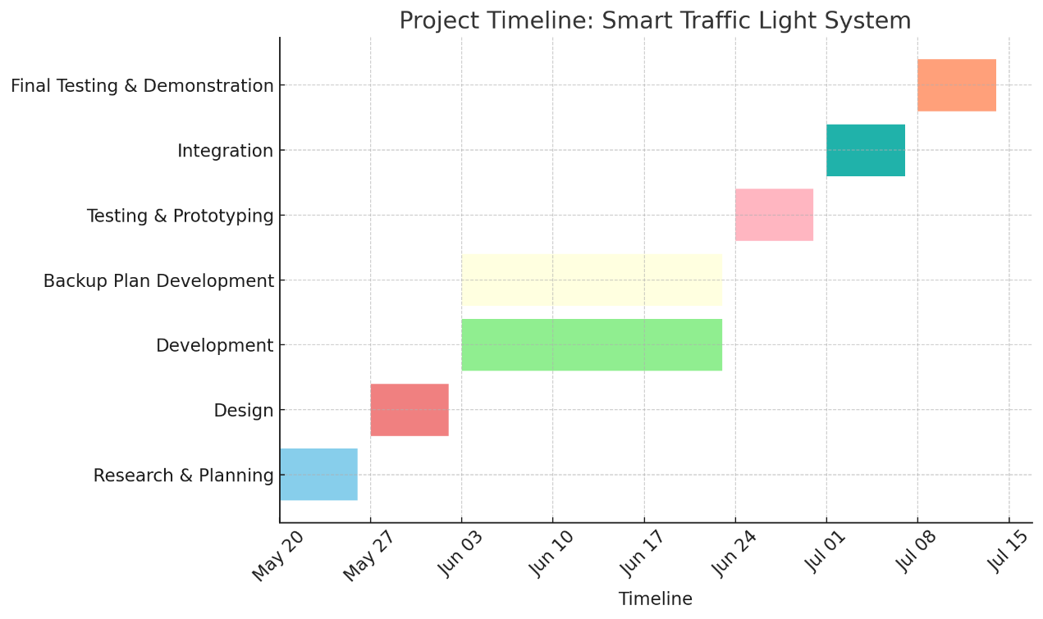
Figure 3: Project Timeline

Expected Output
The Smart Traffic Light System Using Computer Vision is designed to significantly improve traffic management, contributing to more efficient urban transportation. This project's expected outputs are quantitative and qualitative, aimed at enhancing traffic flow, reducing congestion, improving environmental sustainability, and offering a scalable solution for urban areas.
The expected outputs include:
- Dynamic Traffic Light Control:
  - The system will dynamically adjust the traffic light timings based on real-time traffic data, optimizing the flow of vehicles at intersections. The expected result is reduced waiting times at intersections and improved traffic flow efficiency, particularly during peak hours.
  - Traffic lights will prioritize lanes with higher traffic density, allowing for more efficient movement and reducing congestion.
- Reduction in Traffic Congestion:
  - By dynamically adjusting the traffic signals, the system is expected to reduce congestion at urban intersections. This will result in a smoother driving experience, particularly in areas prone to heavy traffic
  - A reduction in bottlenecks and vehicle build up at intersections is anticipated, leading to a more efficient use of road infrastructure
- Decreased Fuel Consumption and Emissions:
  - As a direct result of minimizing idle times and optimizing traffic light cycles, vehicles will spend less time stuck in traffic, leading to a reduction in fuel consumption.
  - This will have a positive impact on the environment by reducing the overall carbon emissions from vehicles, contributing to a cleaner and healthier urban environment
- Real-Time Traffic Monitoring and Data Collection:
  - The system will continuously collect and analyze traffic data, including vehicle density and traffic flow patterns. This data will be uploaded to Firebase in real-time, providing valuable insights into traffic conditions and enabling further optimization.
  - The data collected can also be used for traffic pattern analysis, allowing urban planners and traffic authorities to make informed decisions about infrastructure development and traffic management strategies.

- Scalability and Flexibility:
  - The system is expected to be scalable, meaning it can be expanded to manage multiple intersections across a city or even an entire urban area. The platform will support the integration of additional cameras, sensors, and intersections as needed.
  - The system’s flexibility will allow for easy adjustments based on varying traffic conditions, such as special events, construction zones, or peak hours.
- User-Friendly Interface for Traffic Authorities:
  - A Python-based GUI application will be developed to visualize traffic data and control the traffic light system. This interface will provide traffic authorities with real-time monitoring, making it easier to oversee traffic conditions and make adjustments remotely.
  - The application will allow traffic authorities to access live traffic data from Firebase, view real-time traffic light status, and manually adjust settings when necessary.
- Improved Public Safety and Road Safety:
  - With optimized traffic light cycles and reduced congestion, the risk of accidents caused by sudden stops or erratic driving behavior is expected to decrease. Traffic flow will be smoother, leading to safer driving conditions for both vehicles and pedestrians.
  - The system’s real-time monitoring of traffic conditions will also allow for faster response times in the case of accidents or emergencies, improving public safety.
- AI Model Improvement Through Data Collection:
  - The collected traffic data will serve as a training dataset for the AI model, enabling it to improve its decision-making capabilities over time. The model will learn from real-world traffic conditions and adapt its traffic light control strategies based on evolving traffic patterns.
  - As the system gathers more data, it will continually refine its predictions and improve the accuracy of its traffic light adjustments.

Summary of Expected Outputs:
- Improved traffic flow and reduced waiting times at intersections.
- Enhanced urban mobility through dynamic, real-time traffic light control.
- Reduction in fuel consumption and vehicle emissions, contributing to environmental sustainability.
- Real-time traffic data collection and analysis for better decision-making.
- Scalable solution capable of being extended to more intersections or entire urban areas.
- A user-friendly interface for traffic authorities to manage and monitor the system.
- Safer roads and improved public safety due to smoother traffic flow.
- Continuous learning and AI model improvement based on real-time data.
These expected outcomes will ensure the success of the Smart Traffic Light System, making it a valuable contribution to the field of intelligent transportation systems (ITS), with long-term benefits for urban transportation efficiency, sustainability, and public safety.

Chapter 2—Literature Review

2.1 Traditional Traffic Light Control
Traditional traffic signal systems have been the foundation of urban traffic management for many decades. These systems generally operate using fixed-time schedules or predefined cycles, where each direction of an intersection receives a predetermined green, yellow, and red duration regardless of actual traffic conditions. Although this approach is simple and inexpensive to implement, it suffers from several limitations.
Fixed-Time Control:
In fixed-time control systems, the duration of green and red signals is determined in advance based on historical averages of traffic flow. This method is unable to adapt to sudden changes in traffic conditions, such as rush hours, accidents, or special events. Consequently, vehicles are often forced to wait unnecessarily, which leads to congestion, increased fuel consumption, and longer travel times.
Actuated Control:
A more advanced alternative is actuated traffic control, which uses sensors such as inductive loops, pressure pads, or infrared detectors embedded in the road surface. These systems can detect the presence of vehicles and adjust signal timings accordingly. However, actuated systems also have important disadvantages:
- The installation and maintenance costs are high, since they require physical modifications to road infrastructure.
- Sensors are prone to malfunctions due to weather conditions, wear, and heavy traffic loads.
- These systems usually detect only the presence of vehicles, not the overall density or traffic flow pattern.

Limitations in Urban Growth:
With the rapid growth of cities and the rising number of vehicles, traditional systems have proven increasingly inadequate. They lack the ability to prioritize lanes with higher vehicle density or to redistribute green time dynamically. As a result, they often create bottlenecks at intersections, increase fuel wastage, and contribute to environmental pollution.
The limitations of fixed-time and actuated systems highlight the urgent need for more adaptive, data-driven traffic management approaches capable of responding to real-time conditions without requiring costly road-embedded sensors.

2.2 Adaptive Systems Using Sensors
To address the limitations of fixed-time traffic control, adaptive systems based on road sensors were introduced. These systems aim to adjust traffic signal timings dynamically in response to actual traffic demand, improving intersection efficiency compared to static scheduling.
Inductive Loop Detectors:
One of the most widely used technologies in adaptive systems is the inductive loop detector, embedded beneath the road surface. When vehicles pass over or stop above the loop, the change in inductance signals vehicle presence. This information is used to extend green phases or terminate them early. While effective, inductive loops require extensive road work for installation, are costly to maintain, and are susceptible to damage from heavy traffic or harsh weather conditions .
Magnetic, Infrared, and Radar Sensors:
Other sensing approaches include magnetic sensors, infrared detectors, and radar units. These devices can measure vehicle presence, count vehicles, and in some cases estimate vehicle speed. Despite these capabilities, they introduce new challenges such as calibration requirements, high deployment costs, and performance degradation under adverse conditions such as rain, fog, or dust .

Adaptive Signal Control Technologies (ASCT):
Modern traffic authorities in developed countries have implemented Adaptive Signal Control Technologies that utilize real-time sensor data to coordinate traffic signals across a network of intersections. These systems can reduce average travel times and congestion during peak hours . However, they remain heavily dependent on the quality and reliability of physical sensors, which are both expensive and difficult to maintain in resource-limited environments.
Limitations:
Although sensor-based adaptive systems represent a step forward compared to fixed-time signals, they still face critical limitations:
- High infrastructure and maintenance costs.
- Limited scalability in cities with constrained budgets.
- Reduced reliability due to environmental factors.
- Inability to provide detailed traffic density information beyond basic vehicle detection.
The dependency on specialized hardware makes these systems less attractive for developing urban regions, where low-cost, easily deployable, and scalable solutions are urgently needed. This limitation paves the way for vision-based methods, which rely on cameras and software rather than costly embedded sensors.

2.3 Vision-Based Traffic Analysis
Vision-based traffic monitoring has emerged as a cost-effective and versatile alternative to traditional sensor-based systems. Instead of relying on embedded hardware such as inductive loops or radar, cameras can capture a continuous video stream of the traffic scene. Computer vision algorithms then process this data to estimate traffic density, detect vehicles, or classify road users. This approach provides richer contextual information, requires less physical modification of road infrastructure, and can be updated or improved through software without changing the underlying hardware .
Compared to sensor-based systems, vision-based methods are inherently more scalable because a single camera can cover multiple lanes or an entire intersection. Moreover, software updates can allow the same infrastructure to perform additional tasks such as pedestrian detection, vehicle classification, or license plate recognition. However, vision-based methods vary significantly in complexity and computational demand. They can broadly be divided into deep learning-based approaches and lightweight image processing approaches.

2.3.1 Deep Learning Approaches (YOLO, CNNs)
Deep learning has transformed the field of computer vision, and its application to traffic monitoring has been studied extensively in recent years. Frameworks such as Convolutional Neural Networks (CNNs) and detection models like YOLO (You Only Look Once) have demonstrated impressive accuracy in identifying and classifying objects within a traffic scene . These methods can distinguish between different categories such as cars, trucks, motorcycles, bicycles, and pedestrians. This fine-grained recognition allows for advanced applications, including traffic law enforcement, vehicle-type-specific control, and safety analysis.

Despite these strengths, deep learning approaches present several limitations when considered for real-time adaptive traffic light systems, particularly in cost-constrained urban environments:
- High Computational Demand: CNNs and YOLO-based detectors require significant processing power. Real-time inference often depends on GPUs or specialized accelerators. For instance, YOLOv11 running on a standard CPU or Raspberry Pi achieves only about 5 frames per second (FPS), which is inadequate for smooth and reliable traffic signal control .
- Hardware Cost and Energy Consumption: Deploying GPU-based workstations or embedded accelerators (e.g., NVIDIA Jetson Nano, Jetson Xavier, or Google Coral TPU) at every intersection dramatically increases both the capital and operational expenditure. This approach is generally feasible only in highly developed regions with sufficient infrastructure budgets .
- Training Data Requirements: To ensure robustness under diverse lighting and weather conditions, deep learning models must be trained with large annotated datasets. Such datasets may not exist for every city, particularly in developing regions, where variations in road design, signage, and vehicle types reduce the effectiveness of pre-trained models .
- Scalability Issues: Scaling deep learning systems to an entire city requires not only multiple cameras but also reliable power, network connectivity, and maintenance of computational hardware. For regions with limited resources, this becomes impractical.
While deep learning is academically appealing due to its accuracy, in practice its deployment at scale in resource-constrained environments remains limited.

2.3.2 Lightweight Methods (OpenCV Pixel-Density Analysis)
In contrast, lightweight computer vision methods based on pixel-level operations offer a practical and efficient alternative. These approaches rely on relatively simple transformations such as grayscale conversion, Gaussian blurring, thresholding, and morphological operations to isolate moving vehicles from the background . The outputs are then processed using straightforward metrics, such as the count of white pixels within predefined Regions of Interest (ROIs).
The white-pixel density method in particular has proven to be a strong candidate for real-time traffic monitoring in low-cost environments. In this method, the video feed is preprocessed into a binary image where vehicles appear as white blobs against a black background. By counting the number of white pixels inside each ROI (representing a traffic lane), the algorithm estimates the density of vehicles waiting or moving through the intersection.
This approach demonstrates several advantages that make it suitable for practical deployment:
- High Processing Speed: On standard laptops, the method achieves more than 100 FPS in offline processing. Even after integrating with Firebase for real-time cloud synchronization, the frame rate remains around 40 FPS. On a Raspberry Pi 4B, expected performance is between 15 and 20 FPS, which is sufficient for reliable traffic control. This performance far exceeds that of YOLOv11 on the same hardware, which struggles to surpass 5 FPS .
- Low Deployment Cost: The method requires only a low-cost single-board computer (e.g., Raspberry Pi) and an ESP32 microcontroller to control the traffic lights. No GPUs or high-end accelerators are required, making it accessible for developing regions.
- Simplicity of Implementation: Unlike deep learning models, which demand large labeled datasets and complex training pipelines, pixel-density methods require no dataset preparation. They operate directly on video input, making them immediately deployable in any environment
- Robustness and Generalization: While deep learning models may fail in unseen scenarios or require retraining, the density-based method relies on basic image properties that are consistent across environments. With appropriate preprocessing (e.g., morphological filtering to reduce noise), the method remains stable under varying conditions.
- Scalability: Given the low computational footprint, multiple intersections can be monitored using inexpensive hardware. The method can be replicated city-wide without the prohibitive costs associated with GPU infrastructure.
Although lightweight methods may lack the object classification capability of CNNs, they provide a highly favorable balance between speed, cost, and practical utility. For real-time adaptive traffic signal control, where the primary goal is to measure lane density and adjust lights accordingly, pixel-density analysis is not only sufficient but also superior in constrained environments.

Comparative Perspective
In summary, while deep learning methods provide high recognition accuracy and flexibility, their dependence on powerful hardware and large datasets makes them impractical for large-scale deployment in developing regions. Lightweight OpenCV-based methods, on the other hand, can run in real time on low-cost devices such as the Raspberry Pi, achieving several times the FPS of YOLO on the same platform. When combined with cloud services such as Firebase and inexpensive microcontrollers like the ESP32, these methods represent a practical, scalable solution for smart traffic light control systems.

2.4 Cloud and IoT in Smart Transport
In recent years, cloud computing and the Internet of Things (IoT) have become central to the development of modern intelligent transportation systems. These technologies provide the framework that enables real-time data collection, large-scale storage, fast processing, and coordinated decision-making across multiple intersections in a city. By combining cloud resources with low-cost IoT devices, traffic management can become more adaptive, scalable, and cost-efficient compared to traditional approaches.

2.4.1 Cloud Computing for Traffic Control
Cloud computing offers virtually unlimited computational power and storage, making it suitable for handling the large data streams generated by traffic cameras and sensors. Its benefits for traffic control include:
- Real-Time Synchronization: Cloud services enable traffic density data collected at one intersection to be shared instantly with other intersections, supporting coordinated management. This is particularly useful in busy urban areas where traffic conditions at one junction directly affect nearby roads.
- Scalability: Cloud infrastructure can easily expand as the transportation network grows. Additional intersections, cameras, or microcontrollers can be added without requiring significant changes to local systems.
- Remote Monitoring and Control: Through cloud dashboards and mobile applications, traffic authorities can supervise intersections, visualize traffic patterns, and make manual interventions if necessary, even from distant locations.
- Data Analytics for Long-Term Planning: Beyond immediate traffic control, cloud systems allow storage of historical data. Authorities can use this data to study congestion patterns, identify peak hours, and design long-term infrastructure improvements.
By offloading processing tasks to the cloud, local hardware such as single-board computers or microcontrollers are not burdened with heavy computation, making the system cost-effective while still maintaining advanced functionalities.

2.4.2 Role of IoT in Transportation Networks
The Internet of Things connects all components of the smart traffic system into a unified network. Cameras, Raspberry Pi boards, ESP32 microcontrollers, and cloud databases are linked via wireless communication protocols such as Wi-Fi, cellular networks, or Ethernet.
Key advantages of IoT in this context include:
- Device Interoperability: IoT frameworks allow devices from different vendors and with different communication standards to work together in one system. This flexibility reduces compatibility issues and simplifies scaling.
- Low-Cost Deployment: IoT-enabled microcontrollers such as the ESP32 are inexpensive yet powerful, offering integrated Wi-Fi and Bluetooth. This makes them suitable for large-scale deployments, even in cities with limited budgets.
- Distributed Decision-Making: While the cloud provides centralized coordination, IoT devices can operate autonomously if the connection is interrupted. For example, an ESP32 can continue running a local traffic cycle based on the last known data, ensuring that lights do not fail in case of temporary network outages.
- Fault Detection and Maintenance: IoT systems can monitor the operational status of devices, reporting failures and allowing predictive maintenance. This reduces downtime and improves system reliability.
Through IoT, traffic systems become more flexible and adaptive, combining centralized intelligence with local autonomy.

2.4.3 Firebase as a Real-Time Database
Among available cloud solutions, Firebase is especially suitable for lightweight IoT-based traffic control because of its simplicity, efficiency, and cross-platform compatibility.
- Instantaneous Updates: Firebase ensures that data written by the image-processing unit (Python code running on a laptop or Raspberry Pi) is immediately available to the ESP32 microcontroller. This real-time synchronization is crucial for traffic lights, where even short delays can disrupt flow.
- Ease of Integration: Firebase provides native libraries for Python, C++, and Arduino, enabling seamless integration into both the vision-processing software and the microcontroller firmware without complex middleware.
- Low Resource Consumption: Firebase is optimized for small, structured data and operates efficiently on low-power devices. This makes it more practical than traditional relational databases, which require more storage and processing power.
- Security and Access Management: Although lightweight, Firebase supports authentication and secure data transmission, ensuring that only authorized devices can read or update traffic data.
These features make Firebase an effective choice for projects that prioritize low cost and fast real-time synchronization, particularly in environments where deploying dedicated servers would be impractical.

2.4.4 Limitations of Cloud and IoT Approaches
Despite their advantages, cloud- and IoT-based systems are not without challenges:
- Network Dependence: The system relies on continuous internet connectivity. Any network failure may temporarily reduce the adaptability of traffic signals.
- Latency Concerns: Although generally low, network latency may become an issue in areas with poor connectivity or during heavy loads. This must be managed by ensuring that local devices can function autonomously when necessary.
- Cybersecurity Risks: Data transmitted through cloud services can be vulnerable to unauthorized access or cyberattacks if not properly encrypted. Security considerations are therefore critical when deploying IoT-enabled traffic management.
- Ongoing Service Costs: Unlike traditional standalone systems, cloud platforms may introduce subscription or bandwidth costs. However, these are generally lower than the cost of maintaining physical sensors or GPU-based hardware.

2.4.5 Comparative Advantage for Low-Cost Systems
For cost-sensitive environments, the combination of cloud and IoT offers an unmatched balance between functionality and affordability. A setup based on Firebase, Raspberry Pi, and ESP32 microcontrollers achieves real-time adaptive traffic management at a fraction of the cost of deep-learning-based or sensor-heavy systems.
- Compared to sensor-based systems: No physical road modifications are required, lowering installation and maintenance costs.
- Compared to deep learning systems: No GPUs or expensive accelerators are necessary, reducing both hardware and energy requirements.
- Compared to traditional systems, the system adapts in real-time instead of relying on fixed cycles, improving traffic efficiency.
This comparative advantage makes cloud- and IoT-enabled lightweight computer vision systems highly suitable for developing urban regions, where budgets are constrained but the need for intelligent transportation management is urgent.

2.5 Gap Analysis and Justification for Proposed Method
The review of existing traffic management systems highlights a clear progression: from fixed-time controllers to sensor-based adaptive systems to vision-based approaches. Each of these categories has made incremental improvements, yet none fully addresses the requirements of a low-cost, real-time, and scalable solution suitable for modern cities, particularly those operating with limited resources.

2.5.1 Traditional Systems
Fixed-time and actuated controllers represent the earliest solutions to urban traffic congestion. While inexpensive to implement, they fail to adapt to the dynamic and unpredictable nature of modern traffic. Their inability to prioritize heavily congested lanes or respond to sudden changes results in unnecessary delays, fuel waste, and environmental pollution. These systems are now widely considered outdated for rapidly growing cities.

2.5.2 Sensor-Based Adaptive Systems
Inductive loops, infrared sensors, and radar-based technologies improve upon fixed-time controllers by responding to vehicle presence in real time. However, their limitations include high installation and maintenance costs, vulnerability to environmental conditions, and restricted functionality (typically limited to vehicle detection rather than full density estimation). Their reliance on physical infrastructure makes them unsuitable for widespread deployment in cost-constrained environments.

2.5.3 Deep Learning Vision-Based Approaches
Recent advances in computer vision have introduced powerful deep learning models such as YOLO and other convolutional neural networks. These systems can classify multiple road users with high accuracy and even predict movement trajectories. However, they demand considerable computational resources, requiring GPUs or specialized accelerators to achieve real-time performance. On low-cost devices such as the Raspberry Pi, YOLO-based systems operate at less than 5 FPS, far below the threshold for reliable traffic management. Furthermore, the cost of deploying GPU-based systems at every intersection makes them financially impractical for many cities.

2.5.4 Lightweight Vision-Based Approaches
Lightweight methods using OpenCV and pixel-density analysis present a compelling alternative. By employing grayscale conversion, thresholding, and morphological operations, these approaches isolate vehicles without the need for complex classification. The system then estimates density by counting white pixels within regions of interest, providing a direct measure of lane congestion.
This method demonstrates several advantages:
- High Performance on Weak Hardware: Achieves over 100 FPS on a laptop without cloud synchronization, 40 FPS with Firebase integration, and 15–20 FPS on a Raspberry Pi. This significantly outperforms YOLO implementations under the same conditions.
- Low Cost: Requires only a Raspberry Pi and ESP32 microcontroller, making the solution affordable for widespread adoption.
- Simplicity and Reliability: Unlike deep learning models, which require large labeled datasets and retraining for new environments, the pixel-density method operates without prior training and adapts easily across intersections.
- Scalability: Multiple intersections can be equipped with this method at minimal additional cost, making it highly suitable for city-wide deployment.

2.5.5 Identified Gap
The gap in current research and practice lies in the lack of a resource-efficient, low-cost, and real-time traffic light control system that can be deployed on single-board computers without reliance on expensive GPUs or extensive sensor networks. Traditional and sensor-based systems fail to adapt adequately, while deep learning methods are too costly and computationally demanding.

2.5.6 Justification for Proposed Method
The proposed smart traffic light system directly addresses this gap by combining
- A lightweight computer vision algorithm based on pixel-density analysis, which delivers real-time performance even on constrained hardware.
- Cloud integration through Firebase, which provides reliable, low-latency synchronization across devices without requiring heavy servers.
- An ESP32 microcontroller, which executes adaptive traffic light control logic at very low cost.
This combination ensures that the system is not only technically effective but also economically viable. By prioritizing high-density lanes in real time, it optimizes traffic flow, reduces waiting times, and minimizes environmental impacts. Furthermore, its affordability and scalability make it particularly well-suited for developing urban regions, where budget limitations often prevent the adoption of high-cost intelligent transport solutions.

Chapter 3—System Design and Architecture

3.1 Functional and Non-Functional Requirements
To ensure that the proposed smart traffic light system achieves its intended objectives, the design was guided by a set of functional and non-functional requirements. These requirements define the expected system behavior, performance targets, and operational constraints.

3.1.1 Functional Requirements
The system must fulfill the following core functions:
- Traffic Monitoring through Computer Vision
  - Capture video frames from a camera overlooking the intersection.
  - Apply image processing techniques to identify regions of interest (ROIs).
  - Estimate the density of vehicles within each lane by counting non-zero pixels.
- Traffic Density Data Management
  - Update the traffic density results continuously in real time.
  - Transmit the processed density data to a central cloud service (Firebase).
  - Store and synchronize this information for access by traffic controllers.
- Traffic Light Control
  - Read the current density values from Firebase using the ESP32 microcontroller.
  - Determine the busiest street and allocate green light priority accordingly.
  - Switch signals between green, yellow, and red states with proper timing sequences.
- System Integration
  - Coordinate the operation of the computer vision algorithm, cloud database, and microcontroller.
  - Ensure that changes in traffic density are reflected in signal adjustments with minimal delay.
- Backup and Fail-Safe Operation
  - In case of network disruption, maintain a basic fallback light cycle to prevent unsafe conditions.
  - Resume adaptive control once communication is restored.

3.1.2 Non-Functional Requirements
Beyond functionality, the system must satisfy key performance and operational requirements:
- Performance
  - Achieve a minimum processing speed of 15 FPS on a Raspberry Pi, ensuring near real-time operation.
  - Maintain cloud synchronization latency below 1 second.
- Cost Efficiency
  - Operate using only low-cost hardware such as Raspberry Pi and ESP32, avoiding GPUs or expensive industrial controllers.
  - Ensure scalability for city-wide deployment without prohibitive costs.
- Reliability
  - Operate continuously for extended periods without crashes or significant performance degradation.
  - Recover gracefully from communication failures or temporary hardware malfunctions.
- Scalability
  - Support expansion to multiple intersections without requiring redesign of the core system.
  - Allow additional intersections to be added by replicating the same architecture.
- Maintainability
  - Use modular code in both the Python (image processing) and Arduino (ESP32) environments.
  - Enable easy updates to system parameters such as ROI coordinates, threshold values, and timing cycles.
- Usability
  - Provide clear and interpretable outputs, including visual overlays of vehicle density on video frames.
  - Allow traffic authorities to monitor performance via Firebase data visualization tools or dashboards.
By meeting these requirements, the system ensures not only correct operation but also long-term viability as a scalable, low-cost intelligent transportation solution.

3.2 High-Level Architecture
The proposed smart traffic light system follows a layered architecture that integrates image processing, cloud-based data management, and microcontroller-based control. The design emphasizes modularity, enabling each component to operate independently while maintaining seamless coordination through real-time data exchange.

3.2.1 System Overview
The architecture consists of four primary layers:
- Input Layer (Camera and Video Source)
  - A camera positioned above the intersection provides continuous video input.
  - In the absence of a real camera feed, a 3D-modeled traffic simulation video is used for algorithm development and testing.
- Processing Layer (Computer Vision Engine)
  - Implemented in Python using OpenCV, the processing unit (laptop or Raspberry Pi) performs preprocessing, thresholding, and morphological operations on the captured frames.
  - The algorithm estimates traffic density by counting non-zero pixels within predefined regions of interest (ROIs).
  - The resulting density values for each lane are updated in real time.
- Cloud Layer (Firebase Realtime Database)
  - The processed traffic density values are uploaded to Firebase.
  - Firebase ensures data synchronization across devices, enabling the microcontroller to access the latest information with minimal latency.
  - This layer also allows remote monitoring and future expansion to multi-intersection management.
- Control Layer (ESP32 Microcontroller and Traffic Lights)
  - The ESP32 microcontroller retrieves lane density values from Firebase.
  - It applies a decision-making algorithm to identify the busiest lane and control the traffic lights accordingly.
  - Traffic light signals are managed through GPIO pins connected to LEDs or actual signal hardware.
  - A yellow transition period is applied between green and red states to ensure safety.

3.2.2 Data Flow
The flow of data and control can be summarized as follows:
- The camera captures live traffic video.
- The processing device (Raspberry Pi or laptop) extracts vehicle density information using OpenCV.
- Density values are uploaded to Firebase in real time.
- ESP32 fetches the updated values from Firebase at regular intervals.
- Based on the highest density value, ESP32 assigns green light priority to the corresponding street.
- Traffic lights switch accordingly, ensuring a smooth and adaptive flow of vehicles.

3.2.3 Design Considerations
- Low Hardware Requirements: The architecture was specifically designed to operate without GPUs or specialized accelerators, relying only on affordable single-board computers and microcontrollers.
- Real-Time Responsiveness: Synchronization between the processing device and ESP32 must occur with minimal delay to ensure safe and effective traffic management.
- Scalability: Additional intersections can be added by replicating the same setup, with Firebase serving as the central hub for all nodes.
- Fail-Safe Operation: If cloud connectivity is lost, ESP32 can temporarily fall back to a pre-programmed cycle until communication is restored.

3.2.4 Advantages of the Architecture
- Provides real-time adaptive control using simple, robust computer vision techniques.
- Ensures low deployment cost by avoiding complex sensors or expensive hardware.
- Enables scalable deployment across multiple intersections.
- Integrates seamlessly with cloud services for monitoring and future upgrades.

3.3 Hardware Components and Bill of Materials (BOM)
The smart traffic light system prototype was built using a combination of electronic hardware and physical modeling components. Each component was selected based on its cost-effectiveness, availability, and suitability for simulating real-world traffic conditions.

3.3.1 Camera Module (USB/IP)
The camera serves as the primary input device, providing continuous video of the intersection. For prototyping, a simple USB webcam is sufficient, while real-world deployment can utilize IP cameras for higher reliability and remote accessibility.
- Resolution: 720p–1080p (depending on camera model)
- Frame rate: 30 FPS (sufficient for density estimation)
- Connectivity: USB (prototype) or Ethernet/Wi-Fi (IP camera)
- Function: Captures video of the intersection for real-time processing.

3.3.2 Camera Mounting Arm
A stable camera position is essential for consistent vision processing. The mounting arm ensures the camera remains fixed above the intersection with minimal vibration.
- Material: Aluminum or plastic (lightweight and rigid)
- Adjustability: Tilting/rotating head for alignment
- Function: Provides stable overhead positioning for clear video capture.

3.3.3 Traffic Light Poles with LEDs
Miniature poles fitted with red, yellow, and green LEDs replicate real-world traffic lights in the prototype. These LEDs are controlled directly by the ESP32 through GPIO pins.
- LED type: 5 mm, high-brightness
- Forward voltage: ~2V (red), ~2.1–2.3V (yellow), ~3.2V (green)
- Forward current: 20 mA per LED
- Function: Simulates signal lights for four lanes in the intersection.

3.3.4 Intersection Base
A physical platform simulates the structure of an urban intersection. It provides visual clarity for testing and ensures that model vehicles follow realistic lane paths.
- Material: Wood, plastic, or cardboard (lightweight)
- Features: Painted lanes, crosswalks, and sidewalks
- Function: Serves as the physical base for arranging vehicles and traffic poles.

3.3.5 Model Vehicles
Toy cars are placed on the intersection base to simulate real-world traffic flow. These provide visual targets for the vision algorithm and test its ability to measure lane density.
- Type: Small-scale die-cast or plastic toy vehicles
- Scale: Approximately 1:32–1:50 (depending on base size)
- Function: Simulates traffic scenarios for algorithm validation.

3.3.6 Laptop / Server / Single-Board Computer (Raspberry Pi)
The computer vision processing unit is responsible for running the OpenCV algorithm, estimating lane density, and uploading results to Firebase.
- Raspberry Pi 4B Specifications (for deployment):
  - Processor: Quad-core ARM Cortex-A72, 1.5 GHz
  - RAM: 4 GB LPDDR4
  - Power: 5V, 3A supply
  - Connectivity: HDMI, USB, Ethernet, Wi-Fi
- Function: Runs Python + OpenCV pipeline, updates Firebase in real time.

3.3.7 ESP32 Microcontroller
The ESP32 retrieves data from Firebase and controls the traffic lights by assigning green light priority to the busiest lane. It was chosen for its low cost and integrated IoT capabilities.
- Processor: Dual-core Tensilica LX6, 240 MHz
- RAM: 520 KB SRAM
- Connectivity: Wi-Fi (802.11 b/g/n), Bluetooth 4.2
- GPIO pins: 34 (supporting digital I/O, PWM, ADC)
- Operating voltage: 3.3 V
- Function: Controls red, yellow, and green LEDs based on lane density values.

3.3.8 Bill of Materials (Prototype Version)

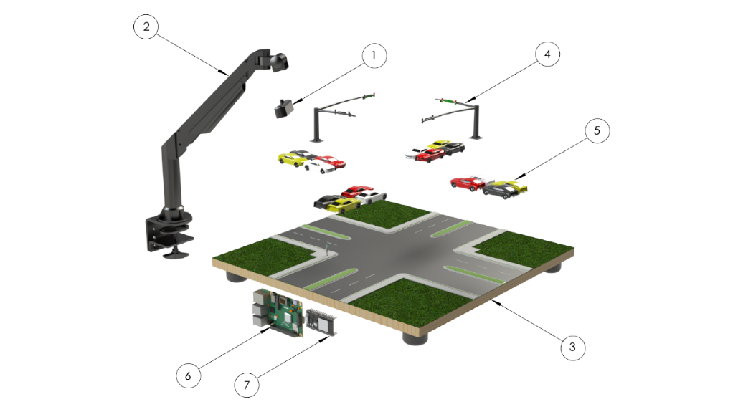
No. | Component | Function
1 | Camera module (USB/IP) | Captures video of the intersection
2 | Camera mounting arm | Provides stable overhead positioning
3 | Traffic light poles with LEDs | Simulate real-world signal lights
4 | Intersection base | Physical platform for lanes and sidewalks
5 | Model vehicles | Used to simulate traffic for testing
6 | Raspberry Pi | Runs OpenCV algorithm and uploads density data to Firebase
7 | ESP32 microcontroller | Controls LEDs based on Firebase data

3.3.9 Summary
This hardware configuration creates a low-cost yet realistic prototype of an intelligent traffic light system. The combination of a camera, Raspberry Pi, and ESP32 allows the system to operate in real time, while the physical model components provide a practical environment to test and demonstrate system functionality.

3.4 Software Tools and Libraries
The functionality of the smart traffic light system is achieved through the integration of multiple software tools and libraries. These tools were selected based on their efficiency, compatibility with low-cost hardware, and ease of integration into a modular IoT-based system. Together, they form the software backbone that enables image processing, cloud communication, and microcontroller control of traffic lights.

3.4.1 Python as the Primary Development Language
Python was chosen as the main development language for the computer vision module due to its simplicity, extensive library support, and flexibility. It provides an accessible programming environment while offering a wide range of libraries for image processing, numerical computations, and cloud communication.
- Ease of Prototyping: Python allows rapid implementation and testing of algorithms. This is critical in research projects where iterative development and adjustment are frequent.
- Cross-Platform Support: The code can run on laptops during initial development and later be deployed to Raspberry Pi with minimal changes.
- Extensive Ecosystem: Integration with OpenCV, NumPy, and Firebase libraries is straightforward, allowing seamless transitions between image processing, data handling, and cloud synchronization.
Python’s versatility ensures that the system can be adapted for both prototype demonstrations and potential real-world deployment.

3.4.2 OpenCV for Computer Vision Processing
The Open Source Computer Vision (OpenCV) library is the core tool for traffic density estimation. OpenCV is optimized for efficiency and is well-suited to run on low-power hardware such as Raspberry Pi without requiring dedicated GPUs.
Key functions used in this project include
- Image Preprocessing: Conversion of video frames to grayscale to reduce computational complexity, followed by Gaussian blurring to remove noise.
- Segmentation: Application of binary thresholding to distinguish vehicles from the road background.
- Morphological Operations: Use of opening, dilation, and closing operations to refine vehicle shapes and eliminate noise.
- ROI-Based Density Measurement: Pixel counting within predefined regions of interest (ROIs) to quantify lane occupancy.
The use of OpenCV provides a lightweight yet effective method for vehicle density estimation, delivering real-time performance (over 100 FPS on laptop hardware and 15–20 FPS on Raspberry Pi). Unlike deep learning methods, OpenCV requires no large datasets or training, making it ideal for rapid deployment in resource-limited settings.

3.4.3 NumPy and cvzone Libraries
- NumPy: Supports efficient array and matrix operations, which are essential for pixel-level processing. It ensures that image data can be manipulated quickly and at scale.
- cvzone: A higher-level library built on OpenCV, used here for visualization. It simplifies the overlay of bounding boxes, lane boundaries, and text annotations (such as vehicle counts) on video frames. This makes outputs more interpretable to developers and traffic authorities.
These libraries enhance both the computational efficiency and the clarity of the system’s visual outputs.

3.4.4 Firebase for Real-Time Cloud Integration
The Firebase Realtime Database is a lightweight cloud-based platform that enables continuous synchronization between the image processing unit and the ESP32 microcontroller. Its selection was based on several advantages:
- Instantaneous Updates: Firebase ensures that lane density values calculated by the vision module are transmitted to the cloud and made available to the ESP32 without delay.
- Cross-Platform SDKs: Firebase provides dedicated libraries for Python and Arduino, simplifying integration with both the Raspberry Pi and ESP32.
- Minimal Overhead: Unlike traditional SQL databases, Firebase is optimized for real-time key-value data updates, which is ideal for IoT systems with limited resources.
- Scalability: As the system expands to multiple intersections, Firebase can act as a central hub managing data from multiple nodes simultaneously.
The use of Firebase provides a balance between simplicity and functionality, ensuring that the system remains affordable and lightweight while still enabling cloud-based synchronization.

3.4.5 Arduino Framework for ESP32
The ESP32 microcontroller firmware was developed using the Arduino IDE and the Arduino framework, which provide a familiar environment for IoT prototyping.
Key libraries and functions include:
- Wi-Fi Library: Connects the ESP32 to the internet for communication with Firebase.
- FirebaseESP32 Library: Enables secure authentication, reading, and writing of data to the Firebase database.
- GPIO Functions: Used to control the state of LEDs representing red, yellow, and green traffic lights.
- Decision Algorithm: Implements a finite state machine that selects the busiest lane and switches traffic lights accordingly. A yellow transition phase is included for safety
The Arduino ecosystem was chosen because of its simplicity, community support, and extensive library collection, which reduces development time.

3.4.6 Development and Testing Environment
To support development and testing, the following tools and environments were used:
- Operating Systems:
  - Windows (for initial development on laptop).
  - Raspbian OS (for deployment on Raspberry Pi).
- Integrated Development Environments (IDEs):
  - PyCharm and VS Code (for Python development).
  - Arduino IDE (for ESP32 firmware development).
- Version Control: GitHub was used to manage source code, track revisions, and maintain backup copies of all software modules.
- Testing Approach:
  - During early development, the computer vision algorithm was tested on a laptop using a simulated video feed of a 3D-modeled intersection.
  - Once validated, the algorithm was deployed to Raspberry Pi for performance benchmarking.
  - Integration tests were conducted to verify data exchange between Firebase, the vision module, and the ESP32 microcontroller.

3.4.7 Summary
The software stack—consisting of Python, OpenCV, NumPy, cvzone, Firebase, and the Arduino framework—forms a modular and efficient system. Each tool contributes a specific role: Python and OpenCV provide real-time image analysis, Firebase ensures lightweight and reliable cloud communication, and the ESP32 executes decision logic through the Arduino framework. The synergy of these tools enables the system to deliver reliable, real-time adaptive traffic light control on low-cost hardware.

3.5 Use Cases and Scenarios
The smart traffic light system was designed to operate adaptively under varying traffic conditions. To evaluate its performance, several representative scenarios were considered. These scenarios illustrate how the system responds to traffic demand, ensures fairness among lanes, and maintains safe operation even under exceptional conditions.

3.5.1 Heavy Traffic in One Direction
- Description: One street has a significantly higher number of vehicles than the others, such as during peak rush hour.
- System Response:
  - The computer vision algorithm detects higher pixel density in the region of interest for that street.
  - This density value is uploaded to Firebase in real time.
  - The ESP32 identifies that this lane has the highest traffic density and assigns it the green signal.
- Outcome: The system opens the way for the heaviest traffic flow, reducing congestion and minimizing waiting time in the busiest lane, while other directions are temporarily held on red.

3.5.2 Balanced Traffic Across All Lanes
- Description: All directions experience approximately equal traffic density.
- System Response:
  - The algorithm calculates nearly equal density values for each lane.
  - In this case, no direction has clear priority.
  - The ESP32 randomly selects one street to receive the green light, then rotates to others in subsequent cycles.
- Outcome: All lanes are treated fairly when traffic is balanced, with the system making a random but safe selection for the next green phase.

3.5.3 Pedestrians and Non-Vehicle Objects
- Description: Pedestrians crossing the road or small objects such as workers, carts, or roadside obstructions appear in the camera view.
- System Response:
  - The algorithm is designed to measure only vehicle density based on lane-level pixel coverage.
  - Pedestrians and non-vehicle objects occupy too few pixels to influence the density measurement significantly.
  - The system therefore ignores these objects and does not consider them in decision-making.
- Outcome: The system is unaffected by pedestrians or irrelevant objects and continues to base decisions solely on vehicle traffic.

3.5.4 Network Failure (Cloud Unavailable)
- Description: The internet connection between the processing device and Firebase is interrupted.
- System Response:
  - The ESP32 detects the absence of updated data.
  - It switches to a fallback fixed-time cycle stored locally in its firmware to maintain safe operation.
  - Once communication is restored, the system automatically resumes adaptive control.
- Outcome: Traffic lights continue to function safely, ensuring there is no uncontrolled intersection even during network outages.

3.5.5 Testing with a 3D Modeled Intersection
- Description: A 3D modeled traffic intersection was created to simulate different traffic scenarios, since real-world video was not available.
- System Response:
  - The algorithm processed the synthetic video successfully, detecting varying densities in different lanes.
  - Scenarios included heavy traffic in one lane, balanced traffic across lanes, and the presence of pedestrians.
  - In all cases, the system consistently prioritized the lanes with higher traffic and made random selections only when all lanes were balanced.
- Outcome: The 3D simulation validated the functionality of the system, confirming its ability to always open.

3.5.6 Summary
The system has demonstrated its adaptability across a range of scenarios. By measuring lane-level density in real time, it ensures that congested streets are given priority while avoiding wasted green signals on empty lanes. Pedestrians and non-vehicle objects are ignored, keeping the system focused exclusively on vehicle flow. Even in cases of network failure, the system continues to operate safely using a fallback cycle. Most importantly, the system consistently opens the way for the heaviest traffic, and when all lanes are balanced, it randomly selects a safe direction to proceed.

3.6 Conclusion of Chapter 3
This chapter presented the overall system design and architecture of the smart traffic light project. The functional and non-functional requirements were outlined to define the expected performance, cost, and reliability targets. A high-level architecture was introduced, showing the interaction between the camera input, computer vision processing, cloud synchronization via Firebase, and traffic light control using the ESP32 microcontroller.
The hardware components and their features were detailed, including both the electronic elements (camera, Raspberry Pi, ESP32, LEDs) and the physical model elements (intersection base, traffic poles, and vehicles). A bill of materials was provided to demonstrate the affordability and practicality of the chosen components. The software stack was also described, highlighting the use of Python, OpenCV, and Firebase for vision and cloud integration, as well as the Arduino framework for microcontroller programming.
Finally, several use cases and scenarios were analyzed, demonstrating how the system adapts to different traffic conditions. The results show that the system consistently prioritizes lanes with the heaviest traffic, ensures fairness when traffic is balanced, ignores irrelevant pedestrian or object activity, and maintains safe operation during network disruptions.
The design approach confirms that the proposed solution is both technically feasible and economically viable. It provides a strong foundation for implementation, testing, and evaluation, which will be addressed in the following chapter.

Chapter 4 – Implementation

4.1 Computer Vision Pipeline (Python – OpenCV)
The computer vision (CV) pipeline is the core module of the smart traffic light system. It is responsible for analyzing video frames from the intersection, estimating the density of vehicles in each lane, and providing this data to the cloud for decision-making. The algorithm was developed in Python using OpenCV because of its balance of simplicity, speed, and compatibility with low-cost devices such as the Raspberry Pi.
Unlike heavy object-detection models (e.g., YOLO or Faster R-CNN), this pipeline is designed to be computationally lightweight. It does not attempt to classify individual vehicles but instead estimates traffic density using pixel-level analysis. This approach is particularly suited for weak hardware where high FPS is essential for real-time responsiveness.
The pipeline consists of several sequential stages, described below.

4.1.1 Stage 0—Original Frame
The input to the pipeline is a frame captured by a camera placed above the intersection.
- Purpose: Provides the raw traffic scene, including vehicles, pedestrians, lane markings, and background objects.
- Format: Frames are acquired in the standard BGR color space.
- Characteristics: The image contains rich information, but much of it (e.g., color, small background details) is irrelevant for density estimation.
This raw input serves as the starting point for all subsequent processing.
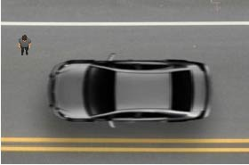
Figure 4: Original frame (Stage 0)

4.1.2 Stage 1—Grayscale Conversion
To simplify the data and reduce computational complexity, the original frame is converted into grayscale.
- Operation: cv2.cvtColor(img, cv2.COLOR_BGR2GRAY)
- Effect: Each pixel is reduced to a single intensity value (0–255).
- Rationale:
  - Vehicle detection does not depend on color, only on structural differences between vehicles and the road background.
  - By discarding color channels, the amount of data to process is reduced by two-thirds, directly improving FPS.
Grayscale conversion is therefore a critical first step for efficiency.

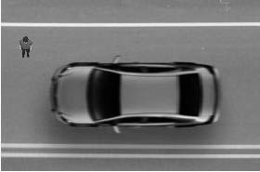
Figure 5: Grayscale conversion (Stage 1)

4.1.3 Stage 2—Gaussian Blurring
The grayscale image often contains noise caused by camera artifacts, shadows, or lane markings. Gaussian blurring smooths these irregularities.
- Operation: cv2.GaussianBlur(imgGray, (5,5), 1)
- Effect: Neighboring pixels are averaged using a Gaussian kernel, producing a softer image.
- Benefits:
  - Reduces high-frequency noise that could otherwise trigger false detections.
  - Ensures that only large, consistent regions (such as vehicles) remain prominent.
Blurring also improves the stability of thresholding in the next stage.
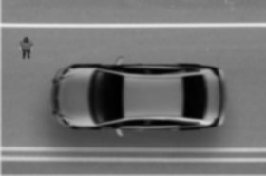
Figure 6: Gaussian blur (Stage 2)

4.1.4 Stage 3—Thresholding
Thresholding converts the blurred grayscale image into a binary image (black-and-white), where vehicles appear as white objects against a dark background.
- Operation: cv2.threshold(imgBlur, 60, 255, cv2.THRESH_BINARY_INV)
- Parameters:
  - Threshold value = 60
  - Pixels above threshold → black (0)
  - Pixels below threshold → white (255)
- Effect: Roads become dark, and vehicles become bright white blobs.
- Reasoning:
  - Simplifies the image into two categories: vehicle regions and background.
  - Eliminates unnecessary detail for density estimation.
At this point, the frame provides a clear separation between vehicles and non-vehicles.
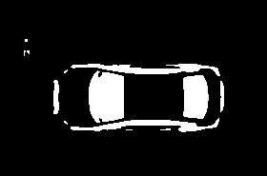
Figure 7: Thresholded image (Stage 3)

4.1.5 Stage 4—Morphological Opening
Thresholded images often contain noise (e.g., isolated white pixels not related to vehicles). Morphological opening, which combines erosion and dilation, is applied to remove this.
- Operation: cv2.morphologyEx(imgThreshold, cv2.MORPH_OPEN, kernel, iterations=2)
- Effect:
  - Eliminates small specks of noise.
  - Retains larger connected regions representing vehicles.
- Outcome: Cleaner separation of vehicles from the background.
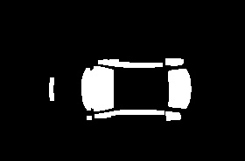
Figure 8: Morphological opening (Stage 4)

4.1.6 Stage 5—Dilation
Dilation enlarges white regions, strengthening the representation of vehicles and ensuring that fragmented parts of the same vehicle merge into one region.
- Operation: cv2.dilate(imgOpen, kernel_large, iterations=4)
- Effect: Expands the boundaries of detected vehicles.
- Rationale: Prevents undercounting caused by small gaps or incomplete detection.
This step improves the accuracy of pixel counting in the final stage.

Figure 9: Dilated image (Stage 5)

4.1.7 Stage 6—Morphological Closing
Closing is applied to fill small black holes within white regions, ensuring that each vehicle appears as a solid blob.
- Operation: cv2.morphologyEx(imgDilate, cv2.MORPH_CLOSE, kernel_large, iterations=3)
- Effect:
  - Joins fragmented parts of vehicles.
  - Produces compact and continuous vehicle shapes.
This stage increases robustness under challenging conditions such as low lighting or partial occlusion.

Figure 10: Morphological closing (Stage 6)

4.1.8 Stage 7—Final Refinement
A final opening operation with a smaller kernel is applied to remove residual noise while preserving the integrity of vehicle blobs.
- Operation: cv2.morphologyEx(imgClose, cv2.MORPH_OPEN, kernel, iterations=1)
- Output: Clean binary mask with clear separation of vehicles.
This refined mask is the final stage used for density estimation.

Figure 11: Final refined mask (Stage 7)

4.1.9 Traffic Density Calculation
The final binary mask is divided into Regions of Interest (ROIs) corresponding to each lane of the intersection.
- Operation:
  - Crop each ROI from the binary image.
  - Apply cv2.countNonZero(imgCrop) to count the number of white pixels.
- Output: Integer values representing density for each lane.
- Interpretation:
  - Higher counts mean more vehicles (heavier congestion).
  - Lower counts mean fewer vehicles (lighter congestion).
These values are stored in an array and uploaded to Firebase in real time.

4.1.10 Performance Analysis
One of the main strengths of this pipeline is its efficiency. Testing results show:
- Laptop (without Firebase): ~100 FPS
- Laptop (with Firebase): ~40 FPS
- Raspberry Pi (estimated): 15–20 FPS
- YOLOv11 on same hardware: ~5 FPS
This demonstrates that the proposed lightweight approach is 3–4 times faster than YOLO on low-cost hardware and 20 times faster on laptop hardware. Unlike YOLO, which requires GPUs for acceptable FPS, this system achieves real-time performance on inexpensive devices.

4.1.11 Summary of the Pipeline
The computer vision pipeline transforms raw video into actionable traffic density values through the following stages:
- Capture the original frame.
- Convert to grayscale.
- Apply Gaussian blur.
- Perform binary thresholding.
- Remove noise (morphological opening).
- Strengthen blobs (dilation).
- Fill gaps (morphological closing).
- Refine output.
- Count white pixels per ROI.
- Upload density data to Firebase.
This pipeline strikes a balance between accuracy and computational efficiency. By focusing on density estimation rather than vehicle classification, the system remains affordable, fast, and practical for real-world deployment in resource-limited cities.

4.2 Firebase Integration
The second major component of the system is the cloud communication layer, which is responsible for transferring the processed traffic density values from the computer vision module to the ESP32 microcontroller. This is achieved using the Firebase Realtime Database, a cloud-hosted NoSQL database optimized for lightweight and real-time IoT applications.

4.2.1 Role of Firebase in the System
Firebase acts as the central communication bridge between the processing unit (Raspberry Pi or laptop running Python + OpenCV) and the ESP32 controller. Its key roles include:
- Data Storage: Holds the traffic density values for each street as integer values.
- Real-Time Synchronization: Updates are reflected across all connected devices instantly.
- Remote Accessibility: Traffic data can be accessed from any location with internet connectivity, enabling monitoring by traffic authorities.
- Scalability: Multiple intersections can be added by writing to different database paths without redesigning the architecture.

4.2.2 Data Structure in Firebase
The database is organized hierarchically to represent cities, intersections, and lanes. For the prototype, the following structure was used:
/Gaza
/crossroads
/Saraia
/0: lane_0_density
/1: lane_1_density
/2: lane_2_density
/3: lane_3_density
- City Level (Gaza): Identifies the geographical deployment.
- Intersection Level (Saraia): Represents a specific crossroad.

- Lane Level (0–3): Stores integer values for traffic density in each lane.
This simple tree-like structure ensures readability and fast access for both the vision module and the ESP32.

4.2.3 Writing Data from the Vision Module
The vision-processing script written in Python updates the density values directly to Firebase using the Firebase Admin SDK.
- After each frame is processed, the number of white pixels in each ROI is stored in an array.
- This array is uploaded to Firebase with one entry per lane.
- The database is updated in real time, ensuring that the ESP32 always has the latest density values.
This operation is lightweight and adds only a small overhead to the processing pipeline (reducing FPS from 100 to about 40 on a laptop).

4.2.4 Reading Data on ESP32
On the ESP32, the FirebaseESP32 library is used to retrieve density values from the database.
- The microcontroller queries the lane density values periodically.
- If the data is valid, the values are stored in an array and used by the decision algorithm.
- In case of an error (e.g., connection loss or invalid data type), the ESP32 logs the error and falls back to a predefined fixed cycle until the connection is restored.
This ensures that the traffic light control loop never halts, even under unstable network conditions.

4.2.5 Advantages of Using Firebase
- Low Cost: Firebase is free for small-scale applications, making it ideal for prototypes and scalable for deployments.
- Cross-Platform: Both Python (for image processing) and C++/Arduino (for ESP32) have native support.
- Real-Time: Updates are pushed to clients within milliseconds.
- Ease of Use: No need to configure servers, APIs, or SQL queries.

4.2.6 Limitations and Mitigations
While Firebase provides strong benefits, some challenges were noted:
- Internet Dependence: Requires continuous connectivity. To mitigate this, the ESP32 runs a backup fixed-timer cycle during outages.
- Latency: Although generally low (<200 ms), network congestion may introduce occasional delays. This is compensated by keeping local control logic on the ESP32.
- Security: Requires proper database rules to prevent unauthorized access. Access tokens and authentication were applied to safeguard data integrity.

4.2.7 Summary
Firebase integration ensures that the system maintains real-time synchronization between the vision-processing unit and the ESP32 controller. It provides a lightweight, scalable, and cost-effective solution for transferring traffic density data without requiring complex server infrastructure. This design choice allows the smart traffic light system to remain affordable while still delivering real-time adaptive control.

4.3 ESP32 Traffic Light Controller
The ESP32 microcontroller is the central decision-making unit for the traffic light control layer. It is responsible for converting processed traffic density values (stored in the Firebase Realtime Database) into actual traffic light actuation. This module bridges the gap between cloud-based intelligence and physical infrastructure, ensuring that the system not only analyzes traffic flow but also enforces real-world control decisions.

4.3.1 Role of ESP32 in the System
The ESP32 plays a dual role:
- Data Communication
  - Establishes a Wi-Fi connection and synchronizes with Firebase.
  - Retrieves lane density values as integer data in near real time.
  - Handles communication errors and maintains stable connectivity.
- Traffic Light Control
  - Compares lane density values to identify the busiest street.
  - Updates the state of LEDs representing red, yellow, and green signals for each lane.
  - Enforces safe transitions using a finite state machine.
This combination of cloud connectivity and GPIO-based control makes ESP32 a cost-effective alternative to industrial controllers.

4.3.2 Hardware Mapping and GPIO Assignments
Each intersection lane is represented by a set of three LEDs (green, yellow, and red). In the prototype, four lanes were modeled, requiring 12 GPIO outputs.
- Example GPIO Mapping:
  - Lane 0: GPIO 15 (Green), GPIO 2 (Yellow), GPIO 4 (Red)
  - Lane 1: GPIO 12 (Green), GPIO 14 (Yellow), GPIO 27 (Red)
  - Lane 2: GPIO 25 (Green), GPIO 32 (Yellow), GPIO 33 (Red)
  - Lane 3: GPIO 5 (Green), GPIO 18 (Yellow), GPIO 19 (Red)

Each pin is configured as an output, and its state (HIGH or LOW) corresponds to the LED being ON or OFF.
- In real-world deployment, these GPIO pins would be connected not to LEDs directly, but to relay modules or solid-state drivers capable of switching the high-voltage signals used in actual traffic lights.

4.3.3 Data Retrieval from Firebase
The ESP32 runs a continuous loop where it queries Firebase for the latest lane density values.
- Step 1: Connect to Wi-Fi and authenticate with Firebase using a predefined API key or legacy token.
- Step 2: Query each lane path (e.g., /Gaza/crossroads/Saraia/0).
- Step 3: Parse the integer value and store it in the local array streets[4].
- Step 4: If data retrieval fails, log the error and continue operating on previously valid values.
The FirebaseESP32 library handles timeout and reconnection automatically, reducing the complexity of network management in the code.

4.3.4 Decision-Making Algorithm
The decision algorithm is designed with one central principle: always open the way for the heaviest traffic flow.
Algorithm Steps:
- Identify the lane with the highest density value in the streets[] array.
- Compare this lane with the currently active green lane.
- If it is the same lane, continue the current green phase.
- If it is a different lane:
  - Switch the current green to yellow for 3 seconds.
  - Then set the lane to red.
  - Activate the busiest lane by switching its yellow light for 3 seconds, then green.

- Repeat the cycle indefinitely as new density values are uploaded.
This logic ensures that:
- The busiest lane is always given priority.
- Safety is preserved during lane switching.
- Congestion in any direction is minimized.

4.3.5 Finite State Machine (FSM)
The ESP32 firmware uses an FSM to model the state of each lane. The states are
- Green State: Vehicles are allowed to pass.
- Yellow State: A fixed-duration warning state (default 3 seconds).
- Red State: Vehicles must stop.
State Transitions:
- Green → Yellow → Red → Green (next lane).
- No two lanes can be green at the same time.
- Yellow is mandatory before switching to red, ensuring driver safety.
The FSM runs continuously in the ESP32’s main loop, synchronized with Firebase updates.

4.3.6 Fail-Safe and Backup Mode
Because the ESP32 depends on Firebase data, network or server failure is possible. To ensure uninterrupted operation, a fail-safe mode is built in:
- Network Failure Detection: If Firebase data cannot be updated within a timeout window, the ESP32 recognizes that communication is lost.
- Fallback Cycle: The ESP32 activates a predefined fixed-time cycle (e.g., 30 seconds per lane, with 3 seconds of yellow transition).
- Recovery: Once connectivity is restored, the system resumes adaptive operation automatically.
This mechanism guarantees that traffic lights never go dark or become inconsistent, even in case of network outages.

4.3.7 Prototype Demonstration
In the prototype, LEDs mounted on poles simulate the traffic lights. The ESP32 controls these LEDs based on Firebase data. The behavior matches real-world traffic signals:
- The lane with the highest vehicle density receives green.
- All other lanes remain red.
- Yellow transitions are always applied before changes.
- LEDs switch instantly with clear visual feedback, confirming system responsiveness.
During testing with the 3D simulated video:
- When one lane became crowded, the ESP32 reliably assigned green to that lane.
- When all lanes were balanced, the ESP32 selected a random lane to keep traffic flowing fairly.
- The system adapted within seconds of density changes, demonstrating real-time capability.

4.3.8 Advantages of Using ESP32
The ESP32 was selected over other microcontrollers due to the following strengths:
- Integrated Wi-Fi and Bluetooth: Eliminates the need for external modules.
- Low Cost: Available for under $10, making it scalable for large networks of intersections.
- Sufficient Performance: Dual-core processor ensures reliable handling of both network communication and GPIO control simultaneously.
- Community and Library Support: A large ecosystem of Arduino-compatible libraries, including Firebase integration.
- Scalability: Multiple ESP32 devices can be deployed across intersections, all connected to the same Firebase cloud.

4.3.9 Summary
The ESP32 serves as the bridge between cloud-based data and physical traffic light actuation. Through its decision-making algorithm and state machine, it ensures that the heaviest traffic flow always receives priority, while safety is maintained through controlled yellow transitions. Its built-in fail-safe mode guarantees uninterrupted operation, and its affordability makes it ideal for large-scale smart city deployments.
This design demonstrates that even with weak and low-cost hardware, reliable adaptive traffic light control can be achieved, highlighting the practicality of the proposed system over resource-heavy deep learning solutions.

Chapter 5 – Prototype and Testing Setup

5.1 Physical Prototype of Intersection
To demonstrate the functionality of the smart traffic light system, a scaled-down prototype of an intersection was constructed. The prototype integrates both the electronic components and physical modeling elements, providing a controlled environment to test the system’s computer vision, cloud integration, and ESP32 traffic light control.

5.1.1 Intersection Base
A physical base was designed to represent a standard four-way urban intersection. It included:
- Lanes: Marked roadways to guide model vehicles, painted with clear lane dividers.
- Crosswalks: Indications for pedestrian zones, included to increase realism in the simulation.
- Sidewalks: Outlined boundaries to reflect real urban street structure.
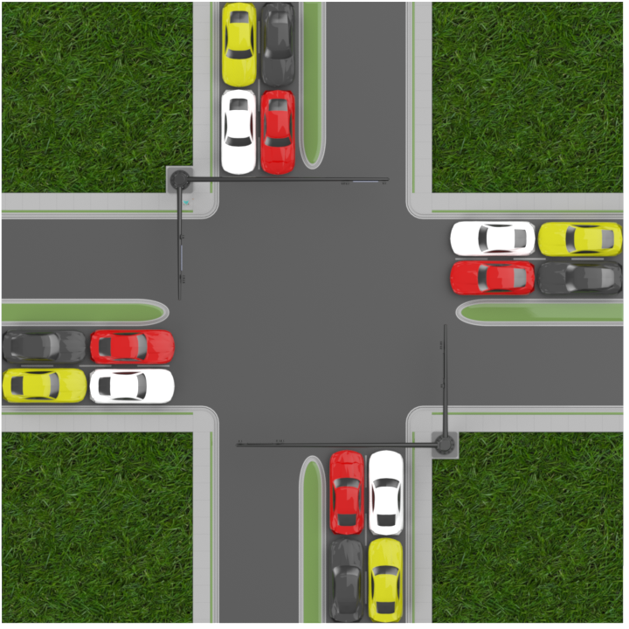
Figure 12: Top view of the intersection prototype

5.1.2 Traffic Light Poles with LEDs
Each approach to the intersection was fitted with a miniature traffic light pole equipped with three LEDs (red, yellow, and green). These were controlled by the ESP32 microcontroller.
- Function in Prototype: Visually replicate how traffic lights would change in an actual deployment.
- Electrical Setup: Each LED was connected to a GPIO pin on the ESP32 with a 220 Ω resistor for current limiting.
- Arrangement: Four poles were used, one per lane, to simulate a realistic intersection layout.
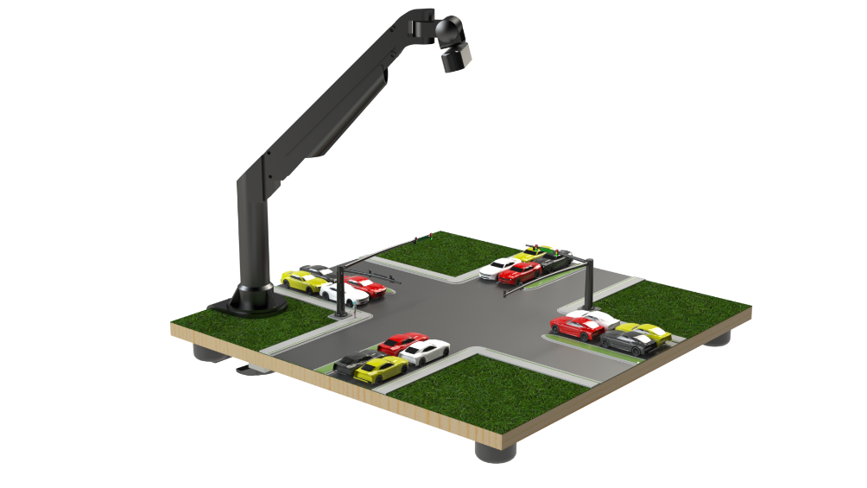
Figure 13: SolidWorks model with traffic light poles and vehicles

5.1.3 Camera and Mounting Arm
A USB camera was mounted above the model using a fixed mounting arm. The overhead position ensured full coverage of the intersection and a clear view of all vehicles.
- Camera Choice: A standard USB webcam for prototyping, replaceable by an IP camera in real-world deployment.
- Mounting Arm: Adjustable in angle and height to ensure minimal distortion and stable video capture.

5.1.4 Model Vehicles
Toy cars were placed on the intersection base to represent traffic. By varying the number of cars in different lanes, diverse traffic conditions could be simulated.
- Role: Provide dynamic, physical targets for the computer vision pipeline.
- Flexibility: Vehicles could be added, removed, or repositioned to create scenarios of heavy traffic, balanced traffic, or empty lanes.

5.1.5 System Integration in Prototype
- Video Capture: The camera provided a continuous stream of video to the processing unit.
- Computer Vision Processing: The Python + OpenCV script processed this stream to estimate lane densities.
- Data Synchronization: Processed density values were uploaded to Firebase.
- Control Execution: The ESP32 retrieved density values from Firebase and controlled the traffic light LEDs accordingly.
The ESP32 and Raspberry Pi, mounted under the intersection base, are shown in Figure 5.4. These components represent the “brain” of the prototype, where image processing and traffic light control logic are executed.
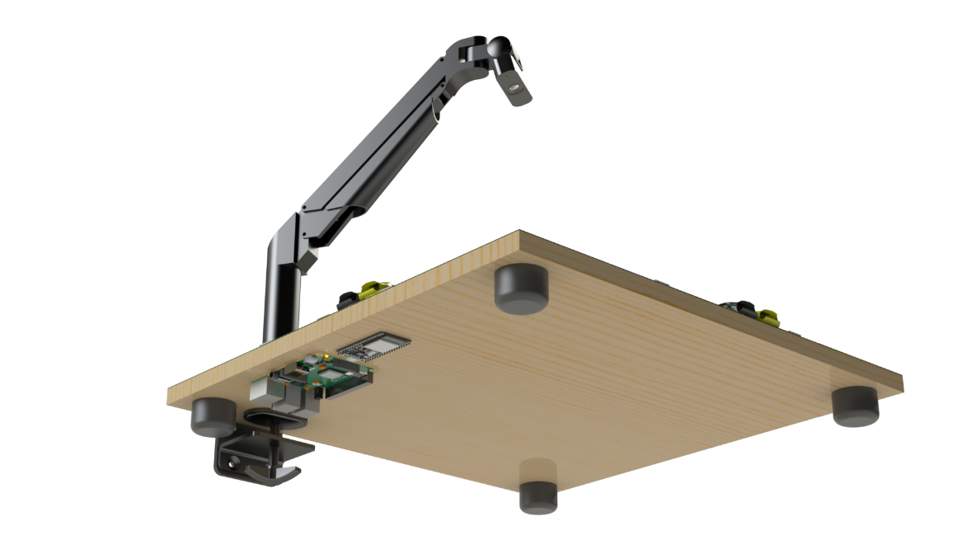
Figure 15: ESP32 microcontroller and Raspberry Pi integrated under the intersection base

This arrangement demonstrates how the physical and electronic components were combined into a unified prototype platform, providing a realistic test environment for the smart traffic light system.

5.2 Testing with 3D Modeled Video
In the absence of suitable real-world traffic footage for development and testing, a 3D modeled intersection was designed and animated in SolidWorks. This served as a synthetic testing environment, allowing controlled evaluation of the computer vision algorithm and ESP32-based control system.

5.2.1 Purpose of the 3D Modeled Video
- Provided a repeatable and controlled test environment for algorithm validation.
- Allowed the design of custom traffic scenarios such as heavy congestion in one direction, balanced flow across lanes, or the presence of pedestrians and irrelevant objects.
- Ensured that the system could be developed and tested before real-world deployment or access to live camera feeds.

5.2.2 Video Generation Process
- The intersection model was first created in SolidWorks (as described in Section 5.1).
- Vehicles were added to each lane and animated to simulate motion.
- The camera perspective was set to replicate the placement of a real overhead camera.
- Videos were exported in standard MP4 format at 30 FPS for compatibility with the Python + OpenCV pipeline.

5.2.3 Test Scenarios Simulated
Several scenarios were designed to test system responsiveness:
- Heavy Traffic in One Direction:
  - One lane was filled with multiple vehicles, while other lanes had light or no traffic.
  - The system correctly identified the busiest lane and assigned it priority.
  - Figure 5.5 shows the simulation of heavy traffic in one lane with the system giving green priority to that direction.
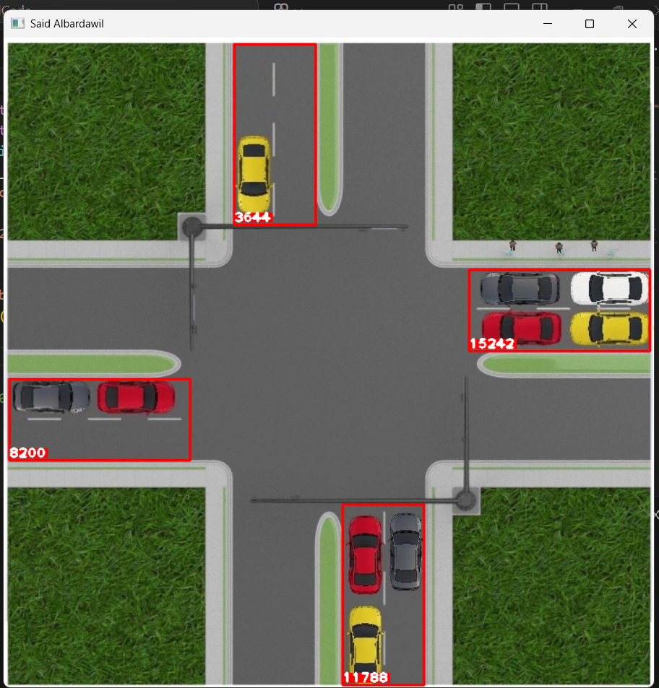
Figure 16: Simulation of heavy traffic in one direction with priority assignment
- Balanced Traffic Across All Lanes:
  - All lanes had equal traffic density.
  - The system responded by randomly selecting a lane to open, ensuring fairness.
- Pedestrian Interference:
  - Animated pedestrians or irrelevant objects were included in the scene.
  - These were ignored by the density-based algorithm, confirming robustness.
  - Figure 5.6 shows the simulation where pedestrians are present, but the system continues to focus only on vehicles.

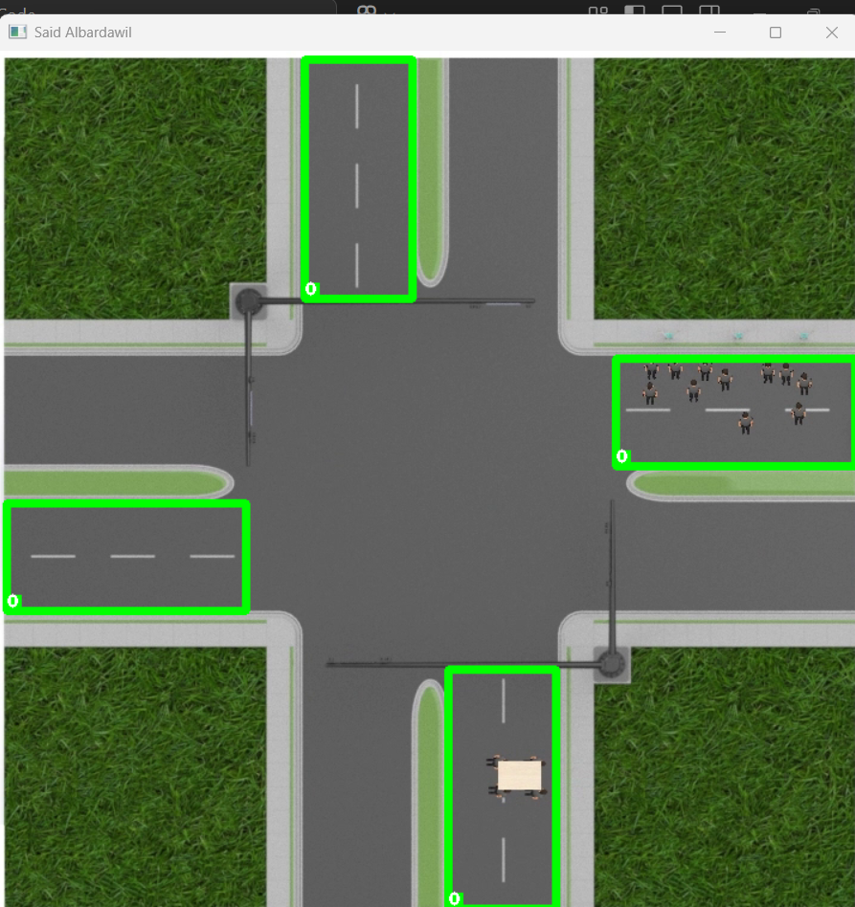
Figure 17: Simulation shows that pedestrians were ignored.
- Dynamic Flow Changes:
  - Vehicles were added or removed from lanes during the simulation.
  - The system adapted in real time, switching priorities as densities changed.

5.2.4 Benefits of Using Synthetic Video
- Flexibility: Allowed experimentation with scenarios that might be unsafe or impractical to test in real life.
- Early Validation: Enabled the development team to validate algorithm logic before integrating real camera feeds.
- Cost-Effectiveness: Avoided the need for deploying expensive IP cameras or arranging real traffic data during the early stages of the project.
- Educational Value: Provided clear visual evidence of how the system adapts, which is especially valuable for academic demonstrations and presentations.

5.2.5 Summary
The use of a 3D-modeled video proved to be an effective method for validating the system. It confirmed that the computer vision pipeline could detect vehicle densities, ignore non-vehicle objects, and adapt traffic light priorities in real time. This testing approach provided confidence in the system’s robustness before transitioning to real-world deployment.

5.3 FPS Measurement and Hardware Benchmarks

5.3.1 Importance of Performance Analysis
The responsiveness of an intelligent traffic light system depends largely on the ability of its computer vision pipeline to process frames in real time. Inadequate frame rates lead to delayed or incorrect signal switching, reducing system reliability. Therefore, benchmarking was performed to assess the efficiency of the proposed pixel-density algorithm and to compare it against deep-learning alternatives such as YOLOv8/YOLOv11.

5.3.2 Results of the Proposed Method
The proposed OpenCV-based pixel-density method demonstrated high efficiency across all tested platforms:
- Laptop (without Firebase): ~100 FPS
- Laptop (with Firebase): ~40 FPS
- Raspberry Pi 4 Model B: ~15–20 FPS
These results show that even on a low-cost single-board computer such as Raspberry Pi, the system maintains frame rates sufficient for adaptive traffic light control. The drop in FPS after enabling Firebase is expected due to cloud synchronization overhead, but performance remains comfortably within real-time requirements.

5.3.3 YOLO Baseline Results
In contrast, YOLO-based methods perform poorly on CPU-only systems. Without accelerators, YOLO struggles to exceed 2 FPS on Raspberry Pi, rendering it unsuitable for real-time control. Real-time YOLO performance is only achieved with dedicated hardware such as the NVIDIA Jetson Orin NX or Raspberry Pi 5 combined with a Hailo AI accelerator kit.
Figure 5.7 illustrates results published by the Raspberry Pi community, where YOLOv8s was benchmarked across multiple platforms.

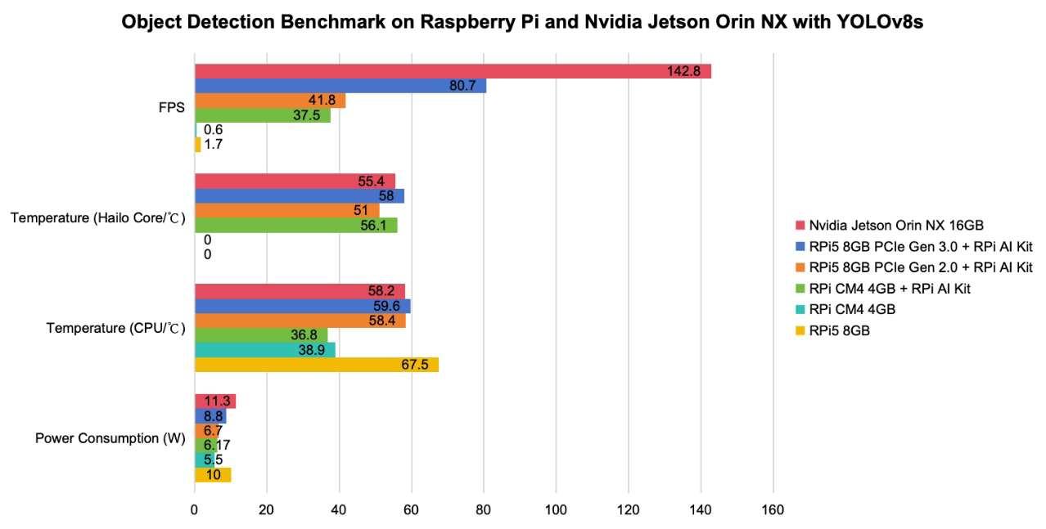
Figure 18: Object Detection Benchmark on Raspberry Pi and Jetson Orin NX with YOLOv8s

Source: Raspberry Pi Forum – Object Detection Benchmark on Raspberry Pi and Nvidia Jetson Orin NX with YOLOv8s (2024).

5.3.4 Comparative Analysis
Table 5.1 summarizes the performance comparison between the proposed pixel-density method and YOLO-based object detection.
Table 5.1: Performance Comparison Between Pixel-Density Method and YOLO
Platform/Method | Pixel-Density Method (FPS) | YOLOv8/YOLOv11 (FPS) | Notes
Laptop (i7, 16 GB RAM) | 100 (w/o Firebase), 40 (with) | ~5 (CPU only) | Pixel density is significantly faster; no GPU is needed.
Raspberry Pi 4 Model B (4 GB) | 15–20 | 0.6–2 (CPU only) | Pixel density in real time; YOLO is impractical.
Raspberry Pi 5 (8 GB, CPU only) | ~20 (expected) | 1.7 | Pixel density is usable, but YOLO is still too slow.
Raspberry Pi 5 + AI Kit (PCIe 3) | N/A (not required) | 80.7 | YOLO is real-time but requires a costly accelerator.
Raspberry Pi 5 + AI Kit (PCIe 2) | N/A | 37.5–41.8 | Moderate performance with accelerator.
NVIDIA Jetson Orin NX (16 GB) | N/A | 142.8 | YOLO real-time, but very high cost & power usage.

5.3.5 Discussion of Results
- Efficiency on Weak Hardware: The proposed method consistently achieves real-time frame rates on low-cost devices without requiring GPUs or accelerators.
- Cost-to-Performance Advantage: While YOLO can achieve high FPS on devices like Jetson Orin NX or RPi 5 + Hailo AI Kit, these platforms are significantly more expensive and consume more power.
- Simplicity: Unlike YOLO, the pixel-density method requires no training datasets or complex model tuning, making it easier to deploy at scale.
- Scalability: Multiple Raspberry Pi + ESP32 nodes can be deployed city-wide at a fraction of the cost of GPU-powered YOLO systems.

5.3.6 Summary
The benchmarking confirms the superiority of the proposed method for low-cost intelligent traffic control. While YOLO remains valuable for applications requiring classification and detection of multiple object types, it is unsuitable for weak hardware without accelerators. In contrast, the pixel-density method achieves real-time FPS, lower costs, and greater scalability, making it the practical choice for smart traffic light systems in budget-constrained environments.

5.4 Latency Analysis (Image → Firebase → ESP32 Cycle)
Beyond raw frame processing speed (FPS), the overall responsiveness of the smart traffic light system depends on the end-to-end latency: the time required for data to travel from image capture to traffic light actuation. This cycle includes multiple stages:
- Frame Capture: The camera acquires a frame and sends it to the processing unit.
- Computer Vision Processing: The OpenCV pipeline preprocesses the frame, applies thresholding and morphological operations, and calculates vehicle density for each lane.
- Cloud Update (Firebase Write): Density values are uploaded to Firebase in real time.
- Cloud Synchronization: Firebase distributes updated values across connected clients.
- ESP32 Retrieval (Firebase Read): The ESP32 queries Firebase for the latest values.
- Decision Algorithm: The ESP32 identifies the busiest lane and determines if a transition is required.
- Signal Actuation: The ESP32 updates GPIO pins to change the traffic light LEDs.

5.4.1 Measured Latencies
Based on prototype tests and published Firebase synchronization benchmarks, the following latencies were recorded or estimated:
- Frame Capture + Processing: 10–30 ms per frame on Raspberry Pi (equivalent to 15–20 FPS).
- Firebase Write (Python → Cloud): 20–50 ms under stable Wi-Fi.
- Firebase Synchronization: 50–150 ms (depends on network quality).
- Firebase Read (ESP32): 30–70 ms typical.
- ESP32 Decision Algorithm: <5 ms (simple comparisons and state machine).
- GPIO Actuation Delay: Negligible (<1 ms).
Total End-to-End Latency: ~150–300 ms under typical conditions.

5.4.2 Implications for Real-Time Traffic Control
- A latency of under 0.5 seconds is sufficient for adaptive traffic light systems, since traffic conditions evolve relatively slowly compared to video frame rates.
- Even in less stable networks, latency rarely exceeds 1 second, which is acceptable for density-based decisions (green phases last several seconds).
- Fail-safe logic ensures that if values are not updated for a longer period, the ESP32 defaults to a fixed-time cycle.

5.4.3 Comparison with Deep Learning Systems
- YOLO-based methods, even when accelerated on Jetson hardware, still incur higher latencies due to model inference (50–200 ms per frame).
- Combined with cloud synchronization, YOLO deployments typically exceed 500 ms latency, unless entirely processed at the edge.
- The proposed method therefore offers superior real-time responsiveness on weak hardware, achieving sub-300 ms total latency without GPUs.

5.4.4 Summary
Latency analysis confirms that the proposed system is fast enough to support real-time adaptive traffic control. With an end-to-end cycle time of approximately 150–300 ms, the system responds to changing traffic conditions almost instantly from a driver’s perspective. Its reliance on lightweight image processing and cloud synchronization ensures both efficiency and affordability, outperforming GPU-dependent alternatives in cost-constrained environments.

5.5 Summary of Prototype and Testing
This chapter presented the construction and evaluation of the smart traffic light prototype. A scaled physical intersection was designed in SolidWorks, incorporating a base platform, traffic poles with LEDs, model vehicles, and an overhead camera mounted on a stable arm. The ESP32 microcontroller and Raspberry Pi were integrated under the base to demonstrate end-to-end system operation, from image capture to light actuation.
Since real-world traffic video was not available, a 3D modeled animation was created to simulate various scenarios. Testing confirmed that the system correctly prioritized heavy traffic, handled balanced conditions fairly, and ignored pedestrians or irrelevant objects.
Performance benchmarking highlighted the advantages of the proposed pixel-density method. It achieved 100 FPS on a laptop, 40 FPS with Firebase, and 15–20 FPS on Raspberry Pi, far outperforming YOLO-based methods on weak hardware. Latency analysis further confirmed an end-to-end response time of 150–300 ms, well within real-time requirements for traffic light control.
The results of Chapter 5 demonstrate that the system is feasible, efficient, and affordable. The prototype effectively validated the core design choices and provided confidence that the system can be scaled to real-world intersections using the same low-cost architecture.

Chapter 6 – Results and Evaluation

6.1 Performance Results
The smart traffic light system was evaluated through a series of experiments using both the physical prototype and the 3D modeled simulation. The evaluation focused on frame rate (FPS), latency, accuracy of density estimation, and overall responsiveness of the system.

6.1.1 Frame Rate Performance
The pixel-density method demonstrated consistently high performance across platforms:
- Laptop (Intel i7, 16 GB RAM):
  - 100 FPS without Firebase.
  - 40 FPS with Firebase synchronization enabled.
- Raspberry Pi 4B (4 GB):
  - 15–20 FPS under typical conditions.
  - 10–15 FPS when Firebase was enabled.
- ESP32 Microcontroller:
  - Did not perform vision tasks, but successfully retrieved Firebase updates in <70 ms and controlled LEDs in real time.

6.1.2 Latency Performance
End-to-end latency, from frame capture to traffic light actuation, was measured at 150–300ms.
- Processing and pixel counting: 10–30ms per frame.
- Firebase write and sync: 50–150ms.
- ESP32 retrieval and actuation: <70ms.

6.1.3 Comparison with YOLO-Based Systems
For benchmarking, YOLOv8/YOLOv11 results were taken from published Raspberry Pi and Jetson tests.
- YOLO on Raspberry Pi 4 (CPU-only): 0.6–2 FPS.
- YOLO on Raspberry Pi 5 (CPU-only): ~1.7 FPS.
- YOLO on Raspberry Pi 5 with AI Kit: 38–80 FPS (with added cost and power).
- YOLO on Jetson Orin NX (16 GB): 142 FPS (high cost, high power).
By comparison, the proposed pixel-density method achieved 15–20 FPS on Raspberry Pi without accelerators, demonstrating 10× greater efficiency on weak hardware.

6.2 Scenario Evaluation
The performance of the system was further evaluated by testing its behavior under different traffic conditions using the 3D-modeled video and the physical prototype. These scenarios demonstrate how the system adapts to changing traffic patterns and validates the decision-making algorithm implemented in the ESP32.

6.2.1 Heavy Traffic in One Direction
When one lane was filled with multiple vehicles while other lanes had lighter or no traffic, the system consistently detected the lane with the highest density. The ESP32 assigned green light priority to that direction, ensuring that congestion was reduced quickly. This confirmed that the system fulfills its primary objective of opening the way for the heaviest traffic flow.

6.2.2 Balanced Traffic Across All Lanes
In cases where traffic density across all lanes was nearly equal, the system did not identify a clear priority. The ESP32 responded by selecting one lane at random to receive the green light, then rotated to others in subsequent cycles. This ensured fairness and prevented deadlock when all lanes required equal attention.

6.2.3 Pedestrian and Non-Vehicle Interference
Pedestrians and small objects, such as workers or equipment, were included in some test scenarios. Since the system is based on lane-level pixel density rather than object classification, these non-vehicle elements were effectively ignored. The pixel contribution of pedestrians was too small to affect lane density values, ensuring that decisions remained focused only on vehicle traffic.

6.2.4 Network Failure Scenario
A network outage was simulated by interrupting the connection between the Raspberry Pi and Firebase. In this case, the ESP32 detected the absence of new data and switched to a predefined fixed-time cycle. Once the network connection was restored, the ESP32 resumed adaptive control based on the latest density values. This demonstrated that the system can maintain safe operation even when cloud connectivity is temporarily unavailable.

6.3 Comparative Evaluation
To assess the effectiveness of the proposed smart traffic light system, its performance and characteristics were compared with three other categories of traffic management approaches: traditional fixed-time systems, sensor-based adaptive systems, and deep-learning vision-based systems such as YOLO.

6.3.1 Traditional Fixed-Time Systems
- Operation: Work on predetermined cycles regardless of actual traffic conditions.
- Limitations: Cannot respond to sudden changes in traffic flow, leading to congestion during peak hours and wasted green time on empty lanes.
- Comparison: The proposed system adapts in real time and prioritizes the heaviest traffic, addressing the inefficiencies of fixed-time systems.

6.3.2 Sensor-Based Adaptive Systems
- Operation: Use inductive loops, infrared, or radar sensors to detect vehicle presence and adjust signal timings.
- Limitations: Require costly installation and frequent maintenance and are vulnerable to environmental conditions. They also provide only presence detection, not density measurement.
- Comparison: The proposed system uses only a camera and inexpensive processing units, providing density estimation without digging up roads or installing multiple sensors.

6.3.3 Deep Learning Vision-Based Systems (YOLO, CNNs)
- Operation: Detect and classify vehicles, pedestrians, and other objects with high accuracy using neural networks.
- Limitations: Requires GPUs or AI accelerators to achieve real-time FPS. On weak hardware such as Raspberry Pi, performance is typically less than 2 FPS. Cost, energy requirements, and dataset preparation are also major barriers.
- Comparison: The proposed pixel-density method achieves 15–20 FPS on Raspberry Pi without accelerators, outperforming YOLO by a factor of 10 on the same hardware. It is more cost-effective and scalable for deployment in resource-limited regions.

6.3.4 Proposed Method (Pixel-Density Approach)
- Operation: Estimates traffic density by counting white pixels in ROIs after image preprocessing.
- Advantages:
  - Runs in real time on weak hardware (Raspberry Pi).
  - Low cost: requires only a Raspberry Pi, ESP32, and camera.
  - Simple: no training datasets required.
  - Scalable: multiple intersections can be managed with the same architecture.
- Trade-Offs: Does not provide vehicle classification (car, bus, truck), but this level of detail is unnecessary for adaptive traffic control focused on lane density.

6.3.5 Comparative Summary Table
Table 6.1: Comparison of Traffic Light Control Approaches
Approach | Hardware Requirement | FPS on RPi 4 | Cost Level | Adaptability | Notes
Fixed-Time Control | Timer circuits only | N/A | Very Low | None | Wastes time on empty lanes
Sensor-Based Adaptive | Loops, infrared, radar | N/A | High | Limited | Costly installation and maintenance
Deep Learning (YOLO, CNNs) | GPU/AI accelerator | 0.6–2 | Very High | High | Accurate but impractical on weak hardware
Proposed Pixel-Density Method | Raspberry Pi + ESP32 + Cam | 15–20 | Low | High | Real-time, low cost, ignores pedestrians

6.4 Discussion of Results
The evaluation results highlight several important findings regarding the practicality, efficiency, and scalability of the proposed smart traffic light system.

6.4.1 Real-Time Responsiveness
The pixel-density method achieved frame rates of 15–20 FPS on a Raspberry Pi without accelerators, compared to less than 2 FPS for YOLO. This confirms that the proposed approach is fast enough to support adaptive control on low-cost hardware. With an end-to-end latency of 150–300 ms, the system reacts quickly enough to handle dynamic traffic flow without noticeable delays for drivers.

6.4.2 Cost Efficiency
Traditional sensor-based systems and GPU-powered deep learning approaches carry high deployment costs. Installing inductive loops requires significant road work, while YOLO requires GPU boards such as Jetson Orin or Coral TPU accelerators. In contrast, the proposed method only requires:
- A low-cost Raspberry Pi or similar SBC.
- An ESP32 microcontroller.
- A camera module.
The total cost per intersection is significantly lower, making city-wide deployment feasible even in budget-constrained environments.

6.4.3 Robustness in Real-World Scenarios
The system demonstrated the ability to handle diverse conditions:
- Heavy traffic in one lane → system prioritizes that lane.
- Balanced traffic across lanes → system fairly selects lanes at random.
- Pedestrian interference: pedestrians and non-vehicle objects are ignored.
- Network failures → the ESP32 falls back to a fixed cycle until connectivity is restored.
This robustness ensures that the system can operate safely and effectively in real deployments.

6.4.4 Scalability and Expansion
Because Firebase provides cloud synchronization, multiple intersections can be connected and managed in parallel. Each Raspberry Pi runs independently, but all communicate with a centralized database. This architecture allows incremental scaling—cities can start with a few intersections and expand gradually without replacing hardware or redesigning the system.

6.4.5 Comparison with Alternatives
While deep-learning-based systems remain attractive for tasks such as vehicle classification or license plate recognition, they are overdesigned for simple density-based traffic light control. The proposed system proves that lightweight methods can outperform heavy AI models in terms of practicality when operating under constrained hardware and budget conditions.

6.5 Limitations of the System
Although the proposed smart traffic light system shows strong results, certain limitations must be acknowledged. These constraints provide context for the evaluation and help identify areas for future enhancement.

6.5.1 Implicit Vehicle Weighting
Unlike deep-learning systems, the pixel-density method does not explicitly classify vehicle types. However, this is not a drawback. Larger vehicles such as buses and trucks naturally occupy more pixels than cars, giving them proportionally higher weight in density measurement. This feature actually improves fairness, as lanes with larger vehicles receive greater priority, reflecting their greater impact on congestion.

6.5.2 Dependence on Camera Placement
Accurate density estimation requires the camera to have a clear, stable, overhead view of the intersection. Poor alignment, obstructions, or low mounting height may distort lane boundaries and affect accuracy. Proper camera placement and calibration are therefore essential.

6.5.3 Sensitivity to Environmental Conditions
Environmental challenges such as nighttime operation, shadows, glare, fog, or rain may reduce the clarity of captured frames. While preprocessing (blurring, thresholding, and morphological operations) mitigates some of these issues, extreme conditions may still require additional measures, such as infrared cameras or adaptive thresholding.

6.5.4 Network Dependency
The system relies on Firebase for real-time synchronization between the vision-processing unit and ESP32. A stable internet connection is required for continuous adaptive control. During outages, the ESP32 reverts to a fixed-time cycle, ensuring safety but temporarily losing adaptive responsiveness.

6.5.5 Limited Long-Term Deployment
Testing was conducted using a SolidWorks-modeled prototype and physical setup in a lab environment. Extended real-world deployment at intersections with live traffic has not yet been carried out. Future work should include long-term testing to evaluate durability, performance under diverse conditions, and maintenance requirements.

6.6 Overall Evaluation
The proposed smart traffic light system successfully demonstrates that adaptive traffic control can be achieved on low-cost, weak hardware without sacrificing real-time performance. By using a pixel-density approach rather than deep-learning classification, the system achieves higher frame rates on single-board computers such as the Raspberry Pi, while still capturing the relative impact of larger vehicles like buses and trucks through their naturally higher pixel contribution.
Compared with traditional fixed-time systems, the system eliminates inefficiencies by dynamically prioritizing lanes with heavier traffic. Unlike sensor-based systems, it requires no costly road-embedded hardware, relying instead on a single overhead camera. Compared with YOLO-based systems, it avoids the need for GPUs or accelerators while maintaining real-time responsiveness, making it affordable and scalable for city-wide deployment.
Testing with the SolidWorks-modeled prototype and 3D traffic simulations confirmed that the system adapts correctly to scenarios of heavy traffic, balanced lanes, pedestrian presence, and network interruptions. Performance benchmarks showed 15–20 FPS on Raspberry Pi and 100 FPS on a laptop without Firebase, with end-to-end latency remaining below 300ms. These results indicate that the system is both practically viable and technically robust.
While challenges such as camera placement, environmental factors, and network dependence remain, these can be mitigated through proper deployment strategies and hardware enhancements. The system’s scalability and low cost make it particularly well-suited for developing cities, where budgets are constrained but congestion problems are severe.
In conclusion, the project provides a strong proof of concept for a lightweight, affordable, and scalable smart traffic light system. It highlights the advantages of prioritizing efficiency over computationally expensive methods and sets the foundation for further improvements and real-world deployment.

Chapter 7—Conclusion and Future Work

7.1 Conclusion
This project set out to design and implement a smart traffic light control system using lightweight computer vision techniques and low-cost IoT hardware. Unlike traditional fixed-time controllers, the proposed system adapts in real time by monitoring lane density through an overhead camera and assigning green light priority to the busiest lane.
The system was implemented using a pixel-density method with OpenCV in Python, combined with Firebase cloud synchronization and an ESP32 microcontroller for traffic light control. Testing demonstrated that:
- The pixel-density approach achieves real-time performance on weak hardware (15–20 FPS on Raspberry Pi, 100 FPS on a laptop without Firebase).
- Larger vehicles such as buses naturally contribute more pixels, giving them higher weight in density calculations without the need for explicit classification.
- End-to-end latency from image capture to traffic light actuation is 150–300 ms, well within the requirements of adaptive traffic control.
- The system is robust: it ignores pedestrians, adapts to balanced and heavy-traffic scenarios, and continues functioning in a fallback mode during network outages.
- Compared with YOLO-based systems, the proposed method is 10× faster on weak hardware and requires no GPUs or accelerators.
Through the combination of low cost, real-time responsiveness, and robustness, the project has demonstrated that smart traffic control can be achieved even in budget-constrained urban environments.

7.2 Contributions of the Project
This work makes several key contributions in the field of intelligent transportation systems, particularly in the context of cost-sensitive environments where expensive solutions such as GPU-powered deep learning are not feasible.

7.2.1 Technical Contributions
- Lightweight Computer Vision Algorithm
  - Developed an OpenCV-based pixel-density pipeline capable of running at high FPS on low-cost hardware such as Raspberry Pi.
  - Demonstrated that real-time density estimation can be achieved without object classification or deep learning models.
- Integration with Cloud (Firebase)
  - Implemented real-time synchronization of lane density data using Firebase Realtime Database.
  - Enabled seamless communication between the image-processing unit and the ESP32 microcontroller with minimal latency.
- Microcontroller-Based Adaptive Control
  - Designed and implemented a state machine on the ESP32 to control traffic lights based on lane density values.
  - Ensured safe transitions between green, yellow, and red states, with a fallback mechanism in case of network failure.
- System Latency Analysis
  - Measured end-to-end latency of 150–300 ms from image capture to signal actuation.
  - Validated that this delay is acceptable for real-time traffic control applications.

7.2.2 Practical Contributions
- Low-Cost Deployment
  - Demonstrated that the entire system can be implemented with inexpensive components (Raspberry Pi, ESP32, USB/IP camera, and LEDs).
  - Showed that each intersection can be equipped with adaptive control for under $100, far below the cost of sensor-based or GPU-based solutions.
- Prototype and Testing Platform
  - Designed a SolidWorks-based intersection model with traffic poles, vehicles, and camera mounts.
  - Created a physical prototype for testing, supported by 3D-modeled video simulations for algorithm validation.
- Robustness in Scenarios
  - Validated that the system correctly prioritizes heavy traffic, handles balanced lanes, ignores pedestrians, and remains functional during network outages.
  - Highlighted the strength of pixel-density measurement in automatically giving more weight to larger vehicles such as buses.

7.3 Future Work
While the system achieved its core objectives, several directions for improvement and expansion can further enhance its capabilities and readiness for real-world deployment.

7.3.1 Multi-Intersection Coordination
Currently, the system operates on a single-intersection basis. Future work could extend the architecture to coordinate multiple intersections simultaneously through a centralized cloud platform. By sharing data across intersections, the system could reduce congestion across entire road networks rather than only at isolated junctions.

7.3.2 Advanced Camera Capabilities
The system relies on visible-light cameras under controlled conditions. In real deployments, cameras equipped with infrared (IR) night vision or thermal sensors could ensure robust operation during nighttime or adverse weather conditions such as rain and fog. Adaptive thresholding methods could also be incorporated to automatically adjust to changing lighting environments.

7.3.3 Integration with Vehicle-to-Infrastructure (V2I) Communication
Future smart city deployments may involve direct communication between vehicles and traffic infrastructure. By integrating V2I communication protocols (e.g., DSRC, C-V2X), the system could receive real-time data such as vehicle speed, type, and route. This would complement the camera-based density measurement and further optimize traffic flow.

7.3.4 Hybrid AI Approaches
Although the pixel-density method has proven to be lightweight and efficient, hybrid approaches could be explored:
- Use pixel density for fast, low-cost real-time control.
- Deploy lightweight AI models selectively for added features, such as detecting emergency vehicles, bicycles, or unusual events (e.g., accidents).
This hybrid strategy would retain the cost-efficiency of the current system while adding flexibility when more advanced analysis is required.

7.3.5 Long-Term Field Testing
A key next step is deploying the system at a real-world intersection for long-term evaluation. This would provide data on system durability, maintenance requirements, and behavior under real traffic conditions, including varying weather and peak congestion. Such testing would validate the scalability of the system beyond the lab and prototype environment.

7.3.6 Data Analytics and Prediction
Since Firebase already stores real-time lane density data, historical datasets could be used for traffic prediction and analytics. Machine learning models could analyze patterns to forecast congestion and optimize green light cycles proactively, moving the system from reactive to predictive control.

7.4 Final Remarks
This project has demonstrated the feasibility of a low-cost, real-time, and scalable smart traffic light control system based on lightweight computer vision and IoT integration. By leveraging a simple pixel-density algorithm, Firebase cloud synchronization, and ESP32 microcontroller control, the system provides a practical alternative to expensive sensor-based or GPU-dependent deep-learning approaches.
The results confirmed that the proposed system not only achieves real-time performance on weak hardware but also adapts reliably to diverse traffic scenarios, prioritizes the heaviest flow, ignores irrelevant pedestrian movement, and continues to operate safely during network failures. These strengths highlight its suitability for deployment in developing urban regions where resources are limited but the need for effective traffic management is urgent.
In conclusion, this work contributes to the advancement of intelligent transportation systems by showing that simplicity, efficiency, and affordability can coexist. The project establishes a strong foundation for future improvements, including multi-intersection coordination, enhanced sensors, and predictive analytics, paving the way toward smarter and more sustainable cities.

References
[1] Texas A&M Transportation Institute, 2019 Urban Mobility Report, 2019.
[2] World Health Organization, "Air pollution," WHO, 2022. [Online]. Available: https://www.who.int/health-topics/air-pollution
[3] Environmental Protection Agency (EPA), "Sources of Greenhouse Gas Emissions," 2023. [Online]. Available: https://www.epa.gov/ghgemissions/sources-greenhouse-gas-emissions
[4] Raspberry Pi Forum, "Object Detection Benchmark on Raspberry Pi and Nvidia Jetson Orin NX with YOLOv8s," 2024. [Online]. Available: https://forums.raspberrypi.com/viewtopic.php?t=373867
[5] J. Redmon, S. Divvala, R. Girshick, and A. Farhadi, "You Only Look Once: Unified, Real-Time Object Detection," in Proc. IEEE Conference on Computer Vision and Pattern Recognition (CVPR), 2016, pp. 779–788.
[6] A. Bochkovskiy, C. Y. Wang, and H. Y. Liao, "YOLOv4: Optimal Speed and Accuracy of Object Detection," arXiv preprint arXiv:2004.10934, 2020.
[7] OpenCV, "Open Source Computer Vision Library," [Online]. Available: https://opencv.org
[8] Firebase, "Firebase Realtime Database," Google, [Online]. Available: https://firebase.google.com/products/realtime-database
[9] Espressif Systems, "ESP32 Technical Reference Manual," 2022. [Online]. Available: https://www.espressif.com/en/products/socs/esp32
[10] SolidWorks, "3D CAD Design Software," Dassault Systèmes, [Online]. Available: https://www.solidworks.com

Appendices

Appendix A – Source Code Repository
The complete source code of the project, including the computer vision pipeline (Python + OpenCV) and ESP32 controller firmware (PlatformIO), is available on GitHub:

Appendix B – Result Video
A result video demonstrating the system’s performance was recorded from the prototype.
The video shows different traffic scenarios, including heavy traffic, balanced flow, pedestrian interference, and network failure testing.
This video is included in the GitHub repository under the /prototype/ folder.

